**GRADE 4 Social Science: Geography – TERM 4**

**Name and surname: _______________________ Total: 50**

**Date: ____________________ Time: 1 hour**

**INSTRUCTIONS**

1. Read the questions carefully.
2. Answer all the questions.
3. Write neatly.

**___________________________________________________________________**

**QUESTION 1**

Define the following words:

* 1. Village (1)

A village is smaller than a town, situated in a rural area.

__________________________________________________________________________________________________________________________________________________________________________________________

* 1. Wastewater (1)

Water that has been used in the home, in a business, or as part of an industrial process. / Water that has been used or contaminated by human activities.

____________________________________________________________________________________________________________________________

* 1. Map symbol (1)

Simple picture or letter used in place of an object.

____________________________________________________________________________________________________________________________

* 1. Water pollution (1)

Water pollution is caused by throwing our waste into rivers and wetlands, by pumping wastewater or letting waste water run into rivers and wetlands from farms, factories, mills and mines.

____________________________________________________________________________________________________________________________

**___________________________________________________________________**

**QUESTION 2**

Is the following statements true or false?

False

2.1. When we purify water, we add dirty and harmful substances. ___________ (1)

2.2. Plants don’t need water for growth and to absorb nutrients from the soil. (1)

False

_____________

2.3. A borehole is a hole which is drilled into the earth to provide us with water. (1)

True

_____________

___________________________________________________________________

**QUESTION 3**

Match Column B with Column A by writing only the letter. (5)

|  |  |  |
| --- | --- | --- |
| Column A | Answer | Column B |
| 1. Rivers | **C** | 1. Areas where the land does not drain well. The ground in is saturated, or full of water. Often the ground is covered with shallow water. |
| 1. Lakes | **D** | 1. A channel of water flowing over the earth. |
| 1. Wetlands | **A** | 1. A natural flowing, moving stream of water. |
| 1. Underground water | **E** | 1. Bodies of water surrounded on all sides by land. Still standing water. |
| 1. Streams | **A** | 1. Water which comes from underground. |

**___________________________________________________________________**

**QUESTION 4**

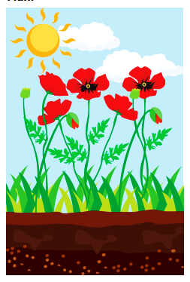Look at the following pictures and describe how water is used by humans, plants and farming. Give 2 examples for each picture. (6)

Plants

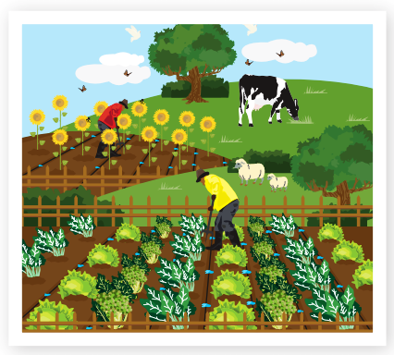

Farming

* Water is needed by the farmer to water his crops for them to grow.
* The farm animals (cow) eat the grass on the farm. The grass needs water to grow in order for the cows to have food.

• Growth

• Maintaining structure

• Absorbing nutrients from the soil



• Growth

• Healthy bodies

• Washing our bodies

• Brushing our teeth

• Flushing the toilet

• Cleaning our house

• Washing clothes

• Washing dishes

• Washing pets

• Washing cars

Humans

**QUESTION 5**

Answer the questions below:

5.1. What is the difference between fresh water and salt water? (2)

Saltwater is found in oceans and seas, while freshwater is found in lakes, rivers and streams. Saltwater contains high amounts of salt, while freshwater only small amounts of salt, but it is not enough to consider it as saltwater.

5.2. Describe the 5 stages of the water cycle. (5)

1. **Evaporation**

This occurs when the sun heats the water in rivers, lakes, dams, icebergs and the ocean and turns it into vapor or steam which floats in the air.

1. **Transpiration**

This occurs when plants make their own food and release water vapor into the air.

1. **Condensation**

This occurs when the vapor in the air gets so cold that it turns back to liquid, forming clouds.

1. **Precipitation**

This occurs when so much water has turned back into liquid that it becomes too heavy to stay up in the air and it falls back to earth in the form of rain, hail, sleet or snow.

1. **Collection**

This occurs when water has fallen back to earth and collects in rivers, lakes, dams and the ocean. Some of it also sinks into the earth and becomes part of what we call ground water.

5.3. Name two ways to store water. (2)

* In water tanks.
* Water bottles.
* Water dams
* Buckets and Pots

___________________________________________________________________

**QUESTION 6**

Describe four ways how people pollute water through their everyday practices. (4)

* Dirty storm water and urban run-off flows into the storm drains in our communities and flows into rivers, wetlands and the ocean.
* Chemicals, soaps and cleaning products run down the drains from our homes.
* Pesticides, herbicides and chemical fertilizers run off farms into rivers, wetlands and the ocean.
* Animal and human waste can be deposited in rivers and streams.
* People throw rubbish into rivers, lakes, dams and the ocean
* Oil spills from ships sailing on the oceans.
* Fishing industry waste is dumped in the oceans.

**QUESTION 7**

Draw a picture to show how water flows from the beginning till the end so that we can receive it in our homes. Your drawing must have titles/headings. Then write an explanation for your picture for 4 points. (9)

√√√√4 marks for drawing of dam, purification plant, reservoir and houses.

√1 mark for titles/headings

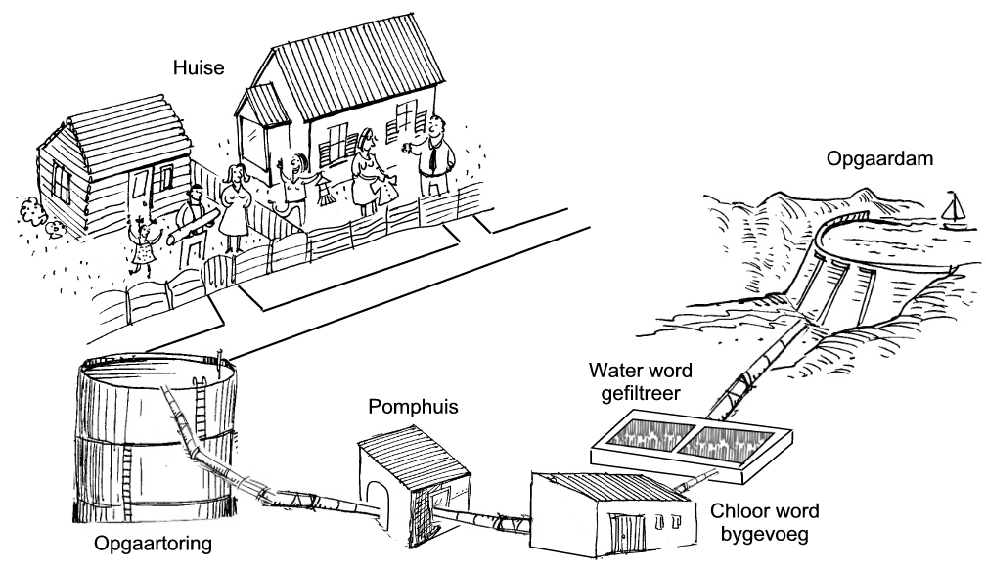

houses

Dams

Purification plant

reservoir

________________________________________________________________________________________________________________________________________________________________________________________________________________________________________________________________________________________________________________________________________________________________________________________________________________

Water travels along pipes from big dams√ to purification plants√, reservoirs √ and finally to taps in communities, homes and other buildings.√

**QUESTION 8**

Use the grid below to answer the questions. (7)

|  |  |  |  |  |
| --- | --- | --- | --- | --- |
|  |  |  |  |  |
|  |  | Image result for school clipart black and white |  | Image result for park clipart black and white |
|  | Image result for school bus clipart black and white | Image result for school children clipart black and whiteImage result for school children clipart black and white |  |  |
|  |  | Image result for supermarket clipart black and white | Related image | Image result for tree clipart black and white |
|  |  |  |  | Image result for bench clipart black and white |

8.1. Identify the names of the objects in the following grid squares: (2)

Tree

School bus

a. B1: _______________ b. C4: _________________

8.2. Give the grid squares of the following objects: (3)

B2 D4

C3 √, D3√

a. Children: ___________ b. Bench: _________________

b. The pond: __________

8.3. Use the 4 cardinal points of a compass.

1. If you are going from A1 to D4, in which direction are you going?

S (South)

_______________________ (1)

1. If you are going from the park to the school bus, in which direction are you going? ____________________ (1)

W (West)

___________________________________________________________________

**QUESTION 9**

Complete the following table by filling in the correct answers. (6 x $\frac{1}{2}=3)$

|  |  |  |  |
| --- | --- | --- | --- |
| **Name of food** | **Plant or animal** | **Processed or unprocessed** | **Which product or animal is this product made from?** |
| 1. Apples | Plant | Unprocessed | Apple tree |
| 1. Bread | Plant | Processed | Wheat |

___________________________________________________________________

**Total: ___/50**