**GRADE 4 Social Science: Geography – TERM 4**

**Name and surname: _______________________ Total: 50**

**Date: ____________________ Time: 1 hour**

**INSTRUCTIONS**

1. Read the questions carefully.
2. Answer all the questions.
3. Write neatly.

**___________________________________________________________________**

**QUESTION 1**

Define the following words:

* 1. Village (1)

__________________________________________________________________________________________________________________________________________________________________________________________

* 1. Wastewater (1)

____________________________________________________________________________________________________________________________

* 1. Map symbol (1)

____________________________________________________________________________________________________________________________

* 1. Water pollution (1)

____________________________________________________________________________________________________________________________

**___________________________________________________________________**

**QUESTION 2**

Is the following statements true or false?

2.1. When we purify water, we add dirty and harmful substances. ___________ (1)

2.2. Plants don’t need water for growth and to absorb nutrients from the soil. (1)

_____________

2.3. A borehole is a hole which is drilled into the earth to provide us with water. (1)

_____________

___________________________________________________________________

**QUESTION 3**

Match Column B with Column A by writing only the letter. (5)

|  |  |  |
| --- | --- | --- |
| Column A | Answer | Column B |
| 1. Rivers |  | 1. Areas where the land does not drain well. The ground in is saturated, or full of water. Often the ground is covered with shallow water. |
| 1. Lakes |  | 1. A channel of water flowing over the earth. |
| 1. Wetlands |  | 1. A natural flowing, moving stream of water. |
| 1. Underground water |  | 1. Bodies of water surrounded on all sides by land. Still standing water. |
| 1. Streams |  | 1. Water which comes from underground. |

**___________________________________________________________________**

**QUESTION 4**

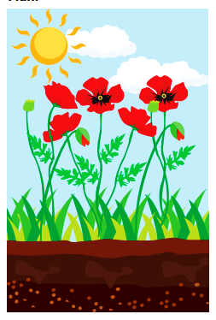Look at the following pictures and describe how water is used by humans, plants and farming. Give 2 examples for each picture. (6)

Plants

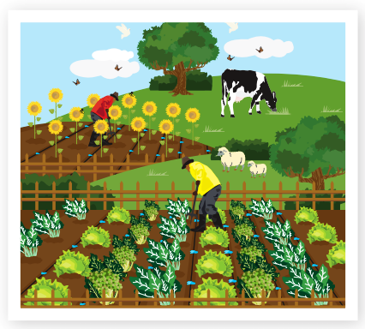

Farming

1. ________________________________________________________________________________________________________________
2. ________________________________________________________________________________________________________________
3. ________________________________________________________________________________________________________________
4. ________________________________________________________________________________________________________________

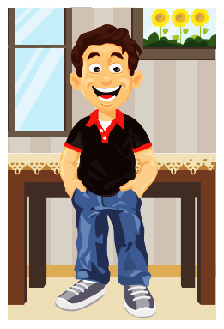

1. ________________________________________________________________________________________________________________
2. ________________________________________________________________________________________________________________

Humans

**QUESTION 5**

Answer the questions below:

5.1. What is the difference between fresh water and salt water? (2)

_______________________________________________________________

_______________________________________________________________

_______________________________________________________________

_______________________________________________________________

5.2. Describe the 5 stages of the water cycle. (5)

____________________________________________________________________________________________________________________________________________________________________________________________________________________________________________________________________________________________________________________________________________________________________________________________________________________________________________________________________________________________________________________________________________________________________________________________________________________________________________________________________

5.3. Name two ways to store water. (2)

_______________________________________________________________

_______________________________________________________________

_______________________________________________________________

_______________________________________________________________

**QUESTION 6**

Describe four ways how people pollute water through their everyday practices. (4)

________________________________________________________________________________________________________________________________________________________________________________________________________________________________________________________________________________________________________________________________________________________________________________________________________________________________________________________________________________________________________________________________________________________

**QUESTION 7**

Draw a picture to show how water flows from the beginning till the end so that we can receive it in our homes. Your drawing must have titles/headings. Then write an explanation for your picture for 4 points. (9)

________________________________________________________________________________________________________________________________________________________________________________________________________________________________________________________________________________________________________________________________________________________________________________________________________________

**QUESTION 8**

Use the grid below to answer the questions. (7)

|  |  |  |  |  |
| --- | --- | --- | --- | --- |
|  |  |  |  |  |
|  |  | Image result for school clipart black and white |  | Image result for park clipart black and white |
|  | Image result for school bus clipart black and white | Image result for school children clipart black and whiteImage result for school children clipart black and white |  |  |
|  |  | Image result for supermarket clipart black and white | Related image | Image result for tree clipart black and white |
|  |  |  |  | Image result for bench clipart black and white |

8.1. Identify the names of the objects in the following grid squares: (2)

a. B1: _______________ b. C4: _________________

8.2. Give the grid squares of the following objects: (3)

a. Children: ___________ b. Bench: _________________

b. The pond: __________

8.3. Use the 4 cardinal points of a compass.

1. If you are going from A1 to D4, in which direction are you going?

_______________________ (1)

1. If you are going from the park to the school bus, in which direction are you going? ____________________ (1)

___________________________________________________________________

**QUESTION 9**

Complete the following table by filling in the correct answers. (6 x $\frac{1}{2}=3)$

|  |  |  |  |
| --- | --- | --- | --- |
| **Name of food** | **Plant or animal** | **Processed or unprocessed** | **Which product or animal is this product made from?** |
| 1. Apples |  |  |  |
| 1. Bread |  |  |  |

___________________________________________________________________

**Total: ___/50**