**GRADE 4 NST – TERM 4**

**MEMORANDUM**

**Name and surname: _______________________ Total: 40**

**Date: ____________________ Time: 1 hour**

**INSTRUCTIONS**

1. Read the questions carefully.
2. Answer all the questions.
3. Write neatly.

**___________________________________________________________________________**

**QUESTION 1**

Read the questions carefully. Draw a circle around the correct letter.

* 1. The Earth is round like a _________ and is made of rock. (1)

1. Square
2. Oval
3. Semi oval
4. Sphere
   1. The following are planets. Which one doesn’t fit? (1)
5. Jupiter
6. Moon
7. Saturn
8. Mars
   1. The Sun is made of hot gas and gives out ____ and ____. (1)
9. light and solar
10. heat and electricity
11. heat and light
12. light and movement
    1. Choose the requirements that most plants need to survive. (1)
13. Water, air and sunlight
14. Rocks, water and food
15. Air, rocks and sunlight

**(Total: __/4)**

___________________________________________________________________________

**QUESTION 2**

Choose a description in column B which fit with Column A and write down the letter.

|  |  |  |
| --- | --- | --- |
| **Column A** | **Answer** | **Column B** |
| Moon | **E** | 1. The Earth moves around the Sun in a pathway called the ____ |
| Atmosphere | **C** | 1. Centre of the solar system |
| Jupiter | **D** | 1. Thin layer of air surrounding the Earth |
| Orbit | **A** | 1. The biggest planet. |
| Sun | **B** | 1. There is no air present. |
| Saturn |  | |

**(Total: __/5)**

___________________________________________________________________________

**QUESTION 3**

Is the following statements TRUE or FALSE?

True

* 1. The sun is a star. ________ (1)

False

* 1. Mars is a blue color. _____ (1)

False

* 1. The Earth is one of ten planets in the solar system. _________ (1)

False

* 1. Pluto is still one of the planets. ________ (1)
  2. The changing pattern of sunlight on the Moon is called the phases of the moon - the pattern repeats every 29 ½ days. ________ (1)

True

**(Total: __/5)**

___________________________________________________________________________

**QUESTION 4**

Underline the correct answer:

* 1. The sun is made out of ( cold / warm ) gas. (1)
  2. The Moon is ( smaller / bigger ) than the Earth. (1)
  3. The Moon is ( further / closer) to the Earth than the Sun. (1)
  4. We cannot see ( sunrays / ultraviolet rays ), but they burn our skin when we are in the sun without sun block. (1)

**(Total: __/4)**

___________________________________________________________________________

**QUESTION 5**

Write the names of the planets in the correct order, start with the planets nearest to the sun.

1. Mercury
2. Venus
3. Earth
4. Mars
5. Jupiter
6. Saturn
7. Uranus
8. Jupiter

**Total ( 8 x $\frac{1}{2}$) = __/4**

___________________________________________________________________________

**QUESTION 6**

Draw a food chain in the block below. You must have 5 organisms in your food chain. Remember to label your food chain. **Total ( 6 x $\frac{1}{2}$) = __/3**

|  |  |  |
| --- | --- | --- |
| Rubric food chain |  | Mark |
| 1. Learner has 5 organisms in his food chain. | 5 |  |
| 1. The learner labeled his organisms |  |  |
| 1. The organisms are places in a logical and correct sequence. | $$\frac{1}{2}$$ |  |
|  | Total | _____/6 |

**QUESTION 7**

Find the words in the word box and circle or color the words.

|  |  |  |  |  |
| --- | --- | --- | --- | --- |
| satellite | star | Neptune | meteor | astronaut |

|  |  |  |  |  |  |  |  |  |  |  |  |
| --- | --- | --- | --- | --- | --- | --- | --- | --- | --- | --- | --- |
| **R** | **S** | **T** | **A** | **R** | **F** | **D** | **L** | **W** | **E** | **A** | **A** |
| **C** | **G** | **D** | **J** | **G** | **O** | **D** | **O** | **O** | **K** | **S** | **S** |
| **R** | **E** | **F** | **L** | **E** | **C** | **T** | **O** | **R** | **K** | **K** | **T** |
| **A** | **C** | **O** | **L** | **I** | **D** | **W** | **X** | **L** | **S** | **S** | **R** |
| **N** | **O** | **M** | **E** | **T** | **E** | **O** | **R** | **G** | **Y** | **A** | **O** |
| **G** | **F** | **G** | **A** | **I** | **C** | **W** | **J** | **U** | **S** | **T** | **N** |
| **E** | **V** | **V** | **X** | **I** | **B** | **T** | **Z** | **L** | **Q** | **E** | **A** |
| **H** | **E** | **X** | **Q** | **W** | **N** | **H** | **E** | **E** | **D** | **L** | **U** |
| **E** | **Q** | **V** | **C** | **T** | **R** | **A** | **N** | **S** | **F** | **L** | **T** |
| **A** | **E** | **Y** | **U** | **J** | **E** | **D** | **F** | **N** | **Y** | **I** | **B** |
| **T** | **T** | **T** | **Z** | **U** | **T** | **K** | **L** | **I** | **G** | **T** | **T** |
| **N** | **E** | **P** | **T** | **U** | **N** | **E** | **R** | **B** | **H** | **E** | **M** |

**(Total: __/5)**

**___________________________________________________________________________**

**QUESTION 8**

Write one word for the following definitions:

* 1. Devises that orbits the Earth and are used to transmit information about the Earth, like climate changes, TV signals, and communication networks are called __________(1)

Saturn

Satellite

* 1. Planet which is famous for the beautiful rings that surround it. ________________(1)
  2. A special kind of scientist that takes a space ship to outer space to study things like asteroids, the Earth's atmosphere and the Moon. __________________ (1)

Astronaut

**(Total: __/3)**

___________________________________________________________________________

**QUESTION 9**

Look at the world map and write down the names of the 7 continents.

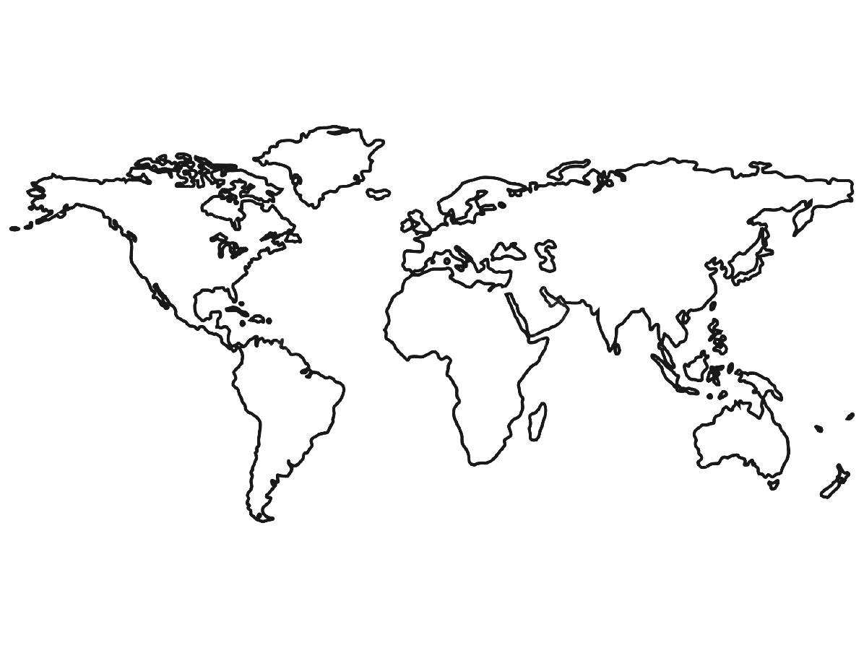

1. Asia
2. Africa
3. North America
4. South America
5. Antarctica
6. Europe
7. Australia

**(Total: __/7)**

**Total: ____/40**