**GRADE 4 Life Skills – TERM 4**

**Name and surname: _______________________ Total: 30**

**Date: ____________________ Time: 45 minutes**

**INSTRUCTIONS**

1. Read the questions carefully.
2. Answer all the questions.
3. Write neatly.

**___________________________________________________________________________**

**QUESTION 1**

Match column B with column A. Write only the letter. (5)

|  |  |  |
| --- | --- | --- |
| **Column A** | **Answer** | **Column B** |
| 1. Air pollution |  | 1. It is a virus. This virus causes an illness called AIDS. |
| 1. Arbor day |  | 1. Traffic sign which instructs motor vehicles to stop. |
| 1. Water pollution |  | 1. Occurs when gases, dust, smoke, or odor get into the air and make it unclean. It is unsafe for humans and animals to breathe and for plants to live with. |
| 1. HIV |  | 1. The contamination of water bodies likes aquifers, ground water, fresh water, rivers, sea and oceans. |
| 1. Stop |  | 1. A holiday in which individuals and groups are encouraged to plant trees. |

___________________________________________________________________________

**QUESTION 2**

Is the following statements true or false? If false correct the statement. (5)

2.1. Germs live in places that are not regularly and properly cleaned. (1)

_____________________________________________________________________

2.2. You only need to brush your teeth once a day. (1)

______________________________________________________________________

2.3. Sweets, fizzy cold drinks and chips are bad for your teeth. (1)

______________________________________________________________________

2.4. Your body doesn’t need healthy food. (1)

______________________________________________________________________

2.5. You should drink lots of water every day. (1)

______________________________________________________________________

___________________________________________________________________________

**QUESTION 3**

Look at the picture and write down 5 traffic rules. (5)

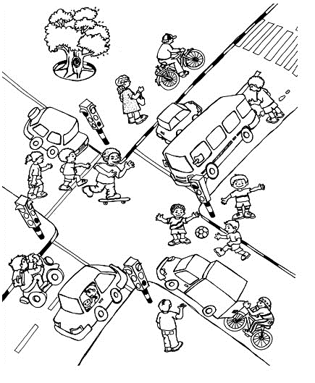

1. ____________________________________________________________________________________________
2. ____________________________________________________________________________________________
3. ____________________________________________________________________________________________
4. ____________________________________________________________________________________________
5. ____________________________________________________________________________________________

**QUESTION 4**

Complete the following sentences by using the words in the word bank. (4 x $\frac{1}{2}=3$)

bully anxious love

hate relaxed

group work

* 1. ____________ is an emotion which makes us feel happy.
  2. When a person calls another person names, spread nasty rumors or hurt them by kicking, hitting, pushing or kicking them, they are called a _____________.
  3. When you fee afraid or nervous you are ____________,
  4. When you work together and help each other it is called _____________.

___________________________________________________________________________

**QUESTION 5**

Answer the following questions:

5.1. For what does the following abbreviations stand for? (2)

1. HIV - ________________________________________________
2. AIDS - _______________________________________________

5.2. How is HIV spread? (2 x $\frac{1}{2}=1$)

______________________________________________________________________

______________________________________________________________________

______________________________________________________________________

______________________________________________________________________

5.3. Look at the pictures an write 3 ways how HIV is not spread. (3)

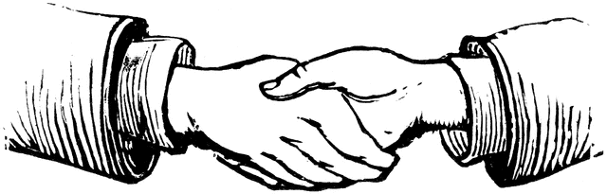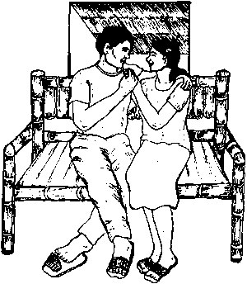

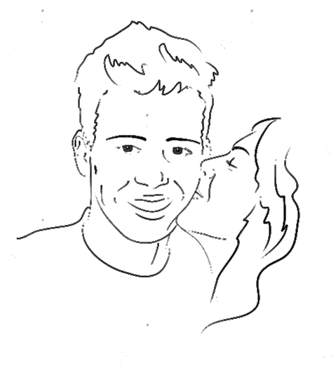

**__________________________________________________________________________________________________________________________________________________________________________________________________________________________________________________________________________________________________________________________________________________________________________________________________________________________________________________________________**

**QUESTION 6**

Look at the pictures and write what type of pollution you see on the line. (3)

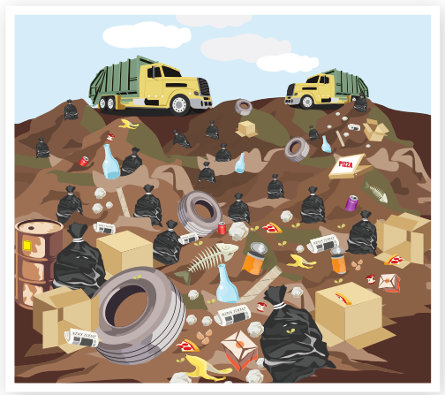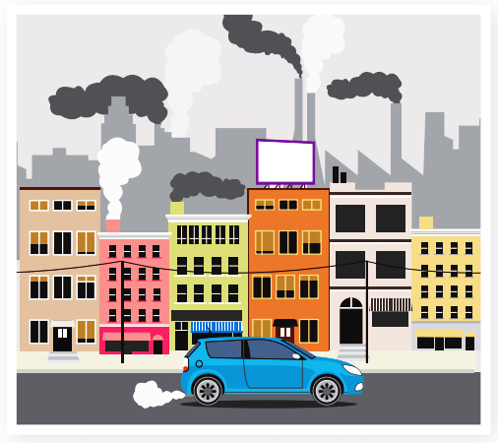

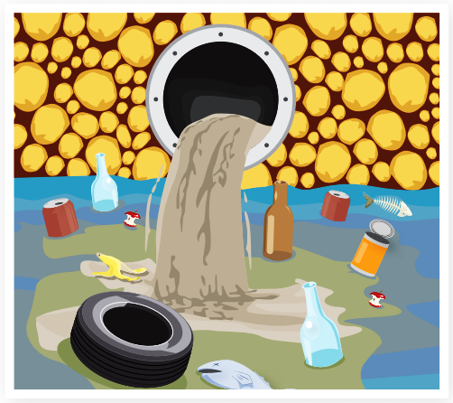

___________________________________________________________________________

**QUESTION 7**

Look at the symbols of each religion below. Write the letter of the symbol next to the correct religion. (6 x $\frac{1}{2}=3$)

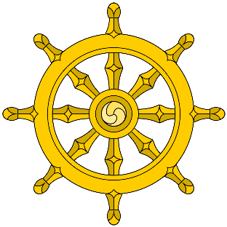



d.

c.

e.

b.

a.

___________________________________________________________________________

**Total: ______/30**

|  |  |
| --- | --- |
| **Religion** | **Symbol** |
| 1. Christian |  |
| 1. Hinduism |  |
| 1. Buddhism |  |
| 1. Islam |  |
| 1. Judaism |  |