**GRADE 4 Life Skills – TERM 4**

**Name and surname: _______________________ Total: 30**

**Date: ____________________ Time: 45 minutes**

**INSTRUCTIONS**

1. Read the questions carefully.
2. Answer all the questions.
3. Write neatly.

**___________________________________________________________________________**

**QUESTION 1**

Match column B with column A. Write only the letter. (5)

|  |  |  |
| --- | --- | --- |
| **Column A** | **Answer** | **Column B** |
| 1. Air pollution | C | 1. It is a virus. This virus causes an illness called AIDS. |
| 1. Arbor day | E | 1. Traffic sign which instructs motor vehicles to stop. |
| 1. Water pollution | D | 1. Occurs when gases, dust, smoke, or odor get into the air and make it unclean. It is unsafe for humans and animals to breathe and for plants to live with. |
| 1. HIV | A | 1. The contamination of water bodies likes aquifers, ground water, fresh water, rivers, sea and oceans. |
| 1. Stop | B | 1. A holiday in which individuals and groups are encouraged to plant trees. |

___________________________________________________________________________

**QUESTION 2**

Is the following statements true or false? If false correct the statement. (5)

2.1. Germs live in places that are not regularly and properly cleaned. (1)

**True**

2.2. You only need to brush your teeth once a day. (1)

**False. You need to brush your teeth twice a day/ a few times a day.**

2.3. Sweets, fizzy cold drinks and chips are bad for your teeth. (1)

**True**

2.4. Your body doesn’t need healthy food. (1)

**False. Our body do need healthy food.**

2.5. You should drink lots of water every day. (1)

**True**

___________________________________________________________________________

**QUESTION 3**

Look at the picture and write down 5 traffic rules. (5)

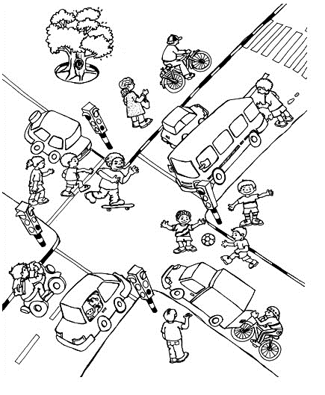

1. Do not play in the road, for example with a ball with your friends.
2. Stop at the red traffic light.
3. You are not allowed to hold onto a moving vehicle while driving on a bicycle.
4. Look left and right before walking over the road.
5. Use the pedestrian crossing to walk over the road.
6. Don’t ride with your skateboard in the middle of the road. Rather ride on the sidewalk.

Any other applicable answers can be correct.

**QUESTION 4**

Complete the following sentences by using the words in the word bank. (4 x $\frac{1}{2}=3$)

bully anxious love

hate relaxed

group work

Love

* 1. ____________ is an emotion which makes us feel happy.
  2. When a person calls another person names, spread nasty rumors or hurt them by kicking, hitting, pushing or kicking them, they are called a _____________.

anxious

bully

* 1. When you fee afraid or nervous you are ____________,

group work

* 1. When you work together and help each other it is called _____________.

___________________________________________________________________________

**QUESTION 5**

Answer the following questions:

5.1. For what does the following abbreviations stand for? (2)

1. HIV - **Human immunodeficiency virus**
2. AIDS - **Acquired immunodeficiency syndrome**

5.2. How is HIV spread? (2 x $\frac{1}{2}=1$)

**One way HIV ·can get into our body is when blood from a person with HIV mixes**

**with the blood of a person not infected with HIV.**

5.3. Look at the pictures an write 3 ways how HIV is not spread. (3)

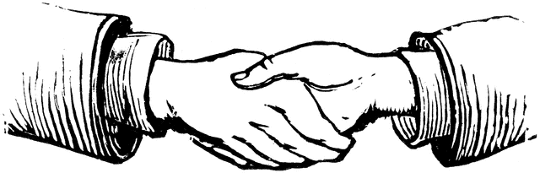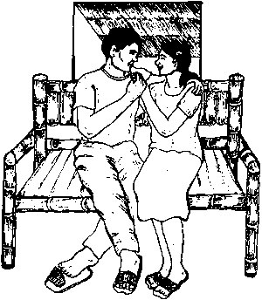

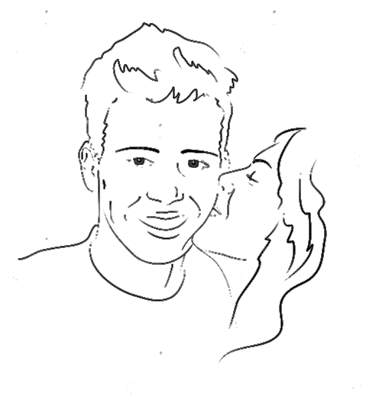

1. HIV cannot be spread by shaking someone’s hand.
2. HIV cannot be spread by holding someone’s hand.
3. HIV cannot be spread by sitting next to someone with HIV.
4. HIV cannot be spread by kissing someone on the cheek.

**___________________________________________________________________________**

**QUESTION 6**

Look at the pictures and write what type of pollution you see on the line. (3)

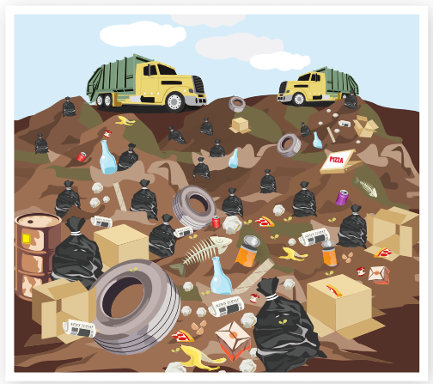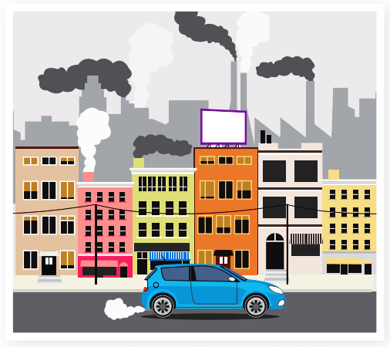

Air pollution Land pollution

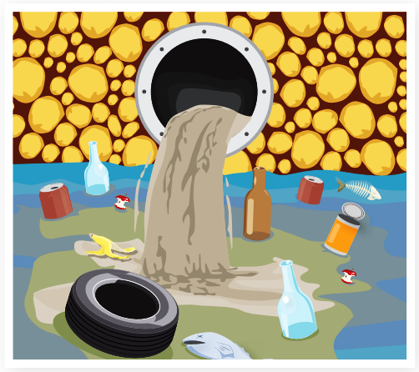

Water pollution

___________________________________________________________________________

**QUESTION 7**

Look at the symbols of each religion below. Write the letter of the symbol next to the correct religion. (6 x $\frac{1}{2}=3$)

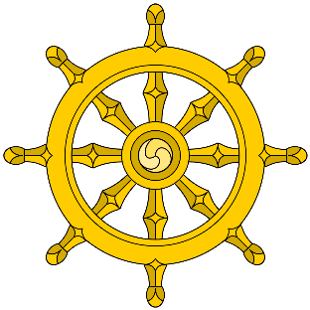



e.

d.

c.

b.

a.

|  |  |
| --- | --- |
| **Religion** | **Symbol** |
| 1. Christian | **c** |
| 1. Hinduism | **a** |
| 1. Buddhism | **d** |
| 1. Islam | **e** |
| 1. Judaism | **b** |

___________________________________________________________________________

**Total: ______/30**