**GRADE 4 ENGLISH HOME LANGUAGE – TERM 4**

**Name and surname: _______________________ Total: 40**

**Date: ____________________ Time: 1 hour**

**INSTRUCTIONS**

1. Read the questions carefully.
2. Answer all the questions in full sentences.
3. Write neatly.

**___________________________________________________________________________**

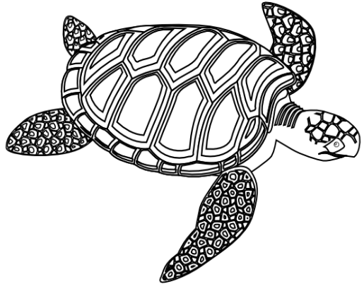**SECTION A**

**QUESTION 1: Comprehension Test**

Read the text about the life of turtles and answer the questions.

**The life of turtles**

Turtles are reptiles. There is two different types of turtles: Land turtles and sea turtles.

Land turtles eat fruit, plants, insects and other animals, whereas sea turtles will eat everything from algae to squid and jellyfish.

Sea turtles return to the same place every two or three years to lay their eggs in the sand of the seashore. Land turtles lay their soft eggs in the sand, dirt, or in grass. They dig holes and deposit the eggs. Some turtles lay only a few eggs. Some can lay over 1,000 at one time. Once the eggs are laid, the turtles move on, leaving the babies to fend for themselves.

Sea turtles live in the ocean. Most sea turtles like to swim in warm oceans. All sea turtles need to breathe air. They cannot breathe air under water, so they swim to the surface often to reach the air.

Sea turtles are like land turtles and freshwater turtles, except most sea turtles are much bigger and they have flippers instead of legs. Some sea turtles are over 112 centimeter long and weigh over 200 kilograms! Sea turtles have been on Earth for over 100 million years. They swam the oceans when dinosaurs walked on land!

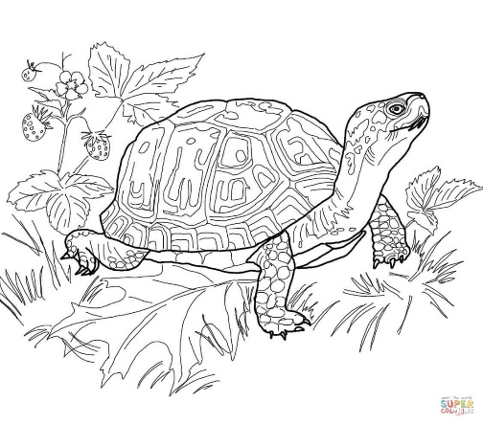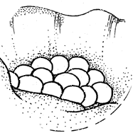

1. Write down 3 differences between a land and a sea turtle. (6)

* Land turtles eat fruit, plants, insects and other animals, whereas sea turtles will eat everything from algae to squid and jellyfish.√√
* Sea turtles are much bigger than land turtles. √√
* Sea turtles have flippers instead of legs like land turtles. √√
* Sea turtles lay their eggs in the sand of the seashore. Land turtles lay their soft eggs in the sand, dirt, or in grass. √√

Any of the above answers are correct. Learners receive one point for the fact of the sea turtle and one point for the fact of the land turtle they compare it with.

1. Write down two facts about a sea turtle. (2)

* Sea turtles will eat everything from algae to squid and jellyfish.
* Sea turtles return to the same place every two or three years to lay their eggs in the sand of the seashore.
* Sea turtles live in the ocean.
* Most sea turtles like to swim in warm oceans.
* All sea turtles need to breathe air. They cannot breathe air under water, so they swim to the surface often to reach the air.
* Some sea turtles are over 112 centimeter long and weigh over 200 kilograms.
* Sea turtles have been on Earth for over 100 million years.
* Sea turtles use flippers.

Any of the above answers are correct.

1. Describe how land turtles and sea turtles lay their eggs. (5)

Sea turtles return to the same place every two or three years to lay their eggs in the sand of the seashore.√ Land turtles lay their soft eggs in the sand, dirt, or in grass. √ They dig holes and deposit the eggs. √ Some turtles lay only a few eggs. Some can lay over 1,000 at one time. √ Once the eggs are laid, the turtles move on, leaving the babies to fend for themselves.√

1. Underline the correct answer:
   1. Turtles are …. (1)
2. Amphibians
3. Reptiles
4. Mammals
5. Fish
   1. Is the following statement TRUE or FALSE? (1)

Sea turtles can breathe air under water.

1. True
2. False

**(Total Question 1: __/15)**

___________________________________________________________________________

**QUESTION 2: Poem**

Read the poem about the turtle and answer the questions.

**Turtles tent**

William Worthless

There was a little turtle his shell it had a leek

The rain was getting in he had not slept all week.

He was very stressed and he began to cry,

spotted by an albatross flying nearby.

The albatross flew down and saw a little crack,

running down the middle of the turtles back.

Don’t worry said the albatross I know the thing to do,

I will get some leaves and make a shelter just for you.

The albatross gathered leaves and made a little tent,

then when it was finished in the turtle went.

The turtle he was happy now in his tent so deep,

he curled his shell and caught up with some sleep.

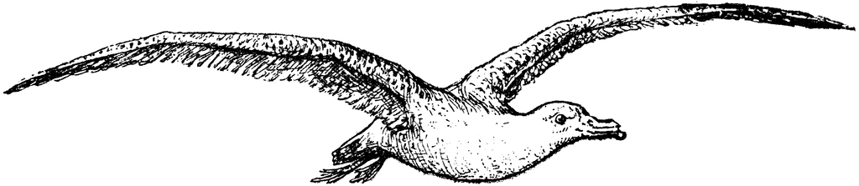

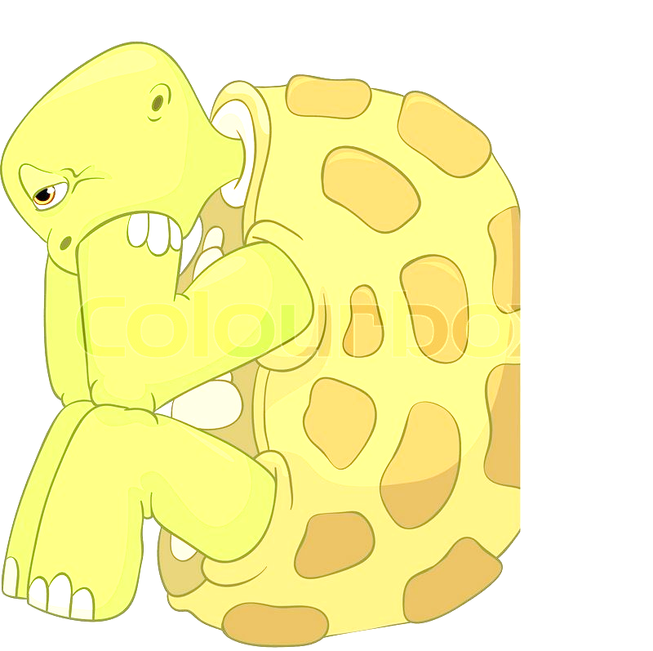

1. Complete the table below. Write an antonym and synonym for the following words. (4)

|  |  |  |  |
| --- | --- | --- | --- |
| **Antonym** | | **Synonym** | |
| little | big | shelter | home, house |
| happy | sad , unhappy | stressed | anxious |

1. Write down two examples of rhyme from the first paragraph of the poem. (2)

Leek and week, cry and nearby.

1. Read the paragraph. Underline the words which rhyme. (2)

The turtle he was happy now in his tent so deep,

he curled his shell and caught up with some sleep.

1. Write down your own word which rhymes with “sleep”. (1)

Creep, sweep, beep or sheep. Any other correct answer will be marked correct.

1. Which one of the following words does not rhyme with “crack”? Underline the correct answer. (1)
2. back
3. snack
4. awake
5. black

**(Total Question 2: __/10)**

**TOTAL SECTION A: ___/25**

___________________________________________________________________________

**SECTION B: Language**

1. Find the adverb and verb in the following sentences. Underline the adverb with blue and the verb with green. (2)

She held her hat tightly in the strong wind.

Tightly – adverb (blue)

Held - verb (green)

1. Write the sentences with the correct capital letters and punctuation marks. (3)
   1. can turtles swim fast asked ben

“Can turtles swim?” asked Ben.

__________________________________________________________________

* 1. watch out

Watch out!

__________________________________________________________________

* 1. land turtles eat fruit plants insects and other animals

Land turtles eat fruit, plants, insects and other animals.

__________________________________________________________________

1. Give the antonyms of the following words: (4 x $\frac{1}{2}=2$)

Pretty

* 1. Ugly - _________________________

Young

* 1. Old - __________________________

Sink

* 1. Float - _________________________

Boy

* 1. Girl - __________________________

1. Complete the table by filling in the singular and plural. (5)

|  |  |
| --- | --- |
| **Singular** | **Plural** |
| branch | **branches** |
| story | **stories** |
| **goose** | geese |
| tooth | **teeth** |
| **puppy** | puppies |

1. Underline the adjectives in the following sentences: (2 x $\frac{1}{2}=1$)
   1. The dog found a large stick.
   2. Everest is the highest mountain.
2. Write the following sentence in the past tense. Only change the underlined words.

The sea turtle swims in the sea. The sea turtle finds it hard to breath under water.

(2 x $\frac{1}{2}=1$)

The sea turtle **swam** in the sea. The sea turtle **found** it hard to breath under water.

_______________________________________________________________________________________________________________________________________________________________________________________________________________

1. Join the following sentences using the conjunctions. (2 x )

and

* 1. Lucy _____ Mary are sisters.

but

* 1. Sean wanted to play cricket, __________ his father wanted him to play rugby.

**TOTAL SECTION B: ___/15**

___________________________________________________________________________

**Total (SECTION A + SECTION B): ____/40**