

Mathematics
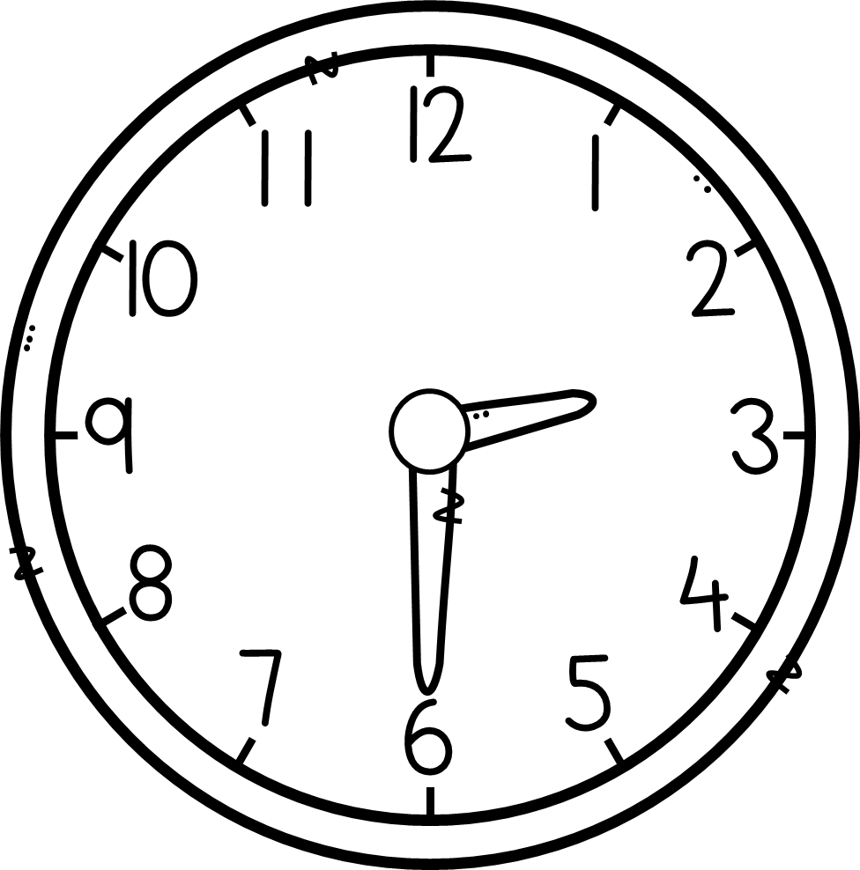
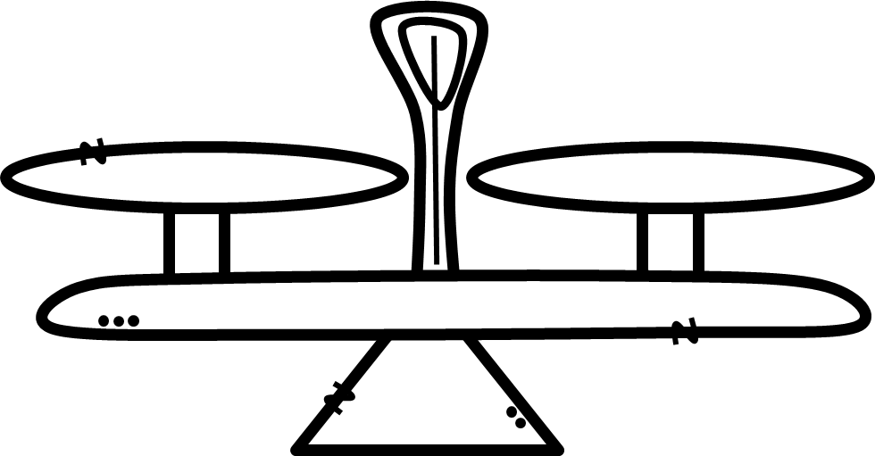
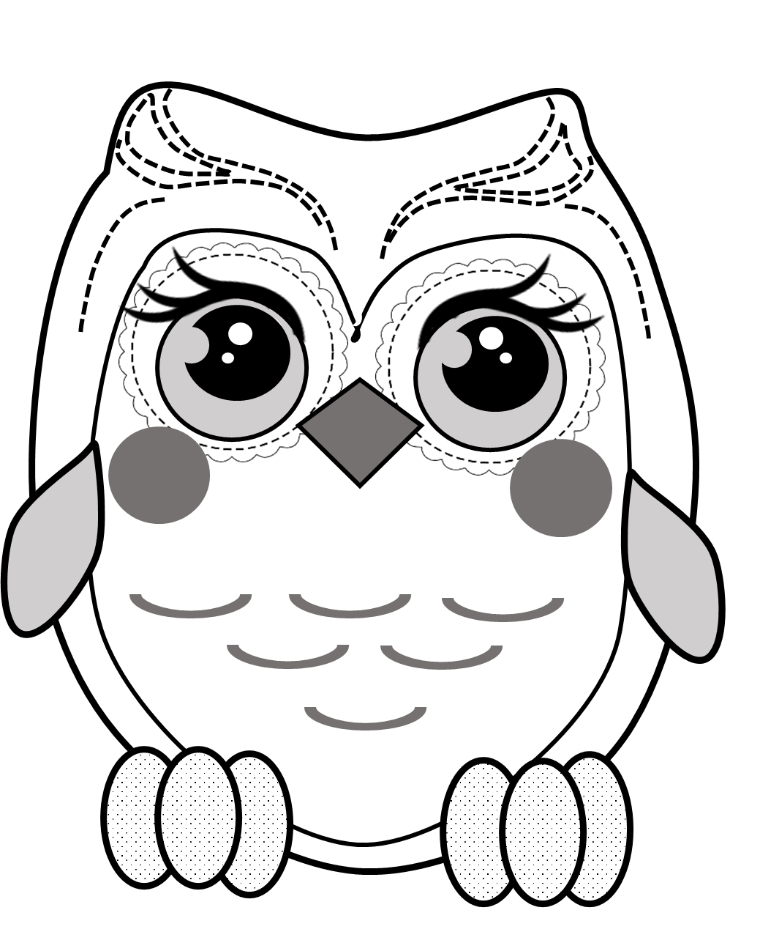
Name: ________________
Grade: 3.2
S. Sparrius
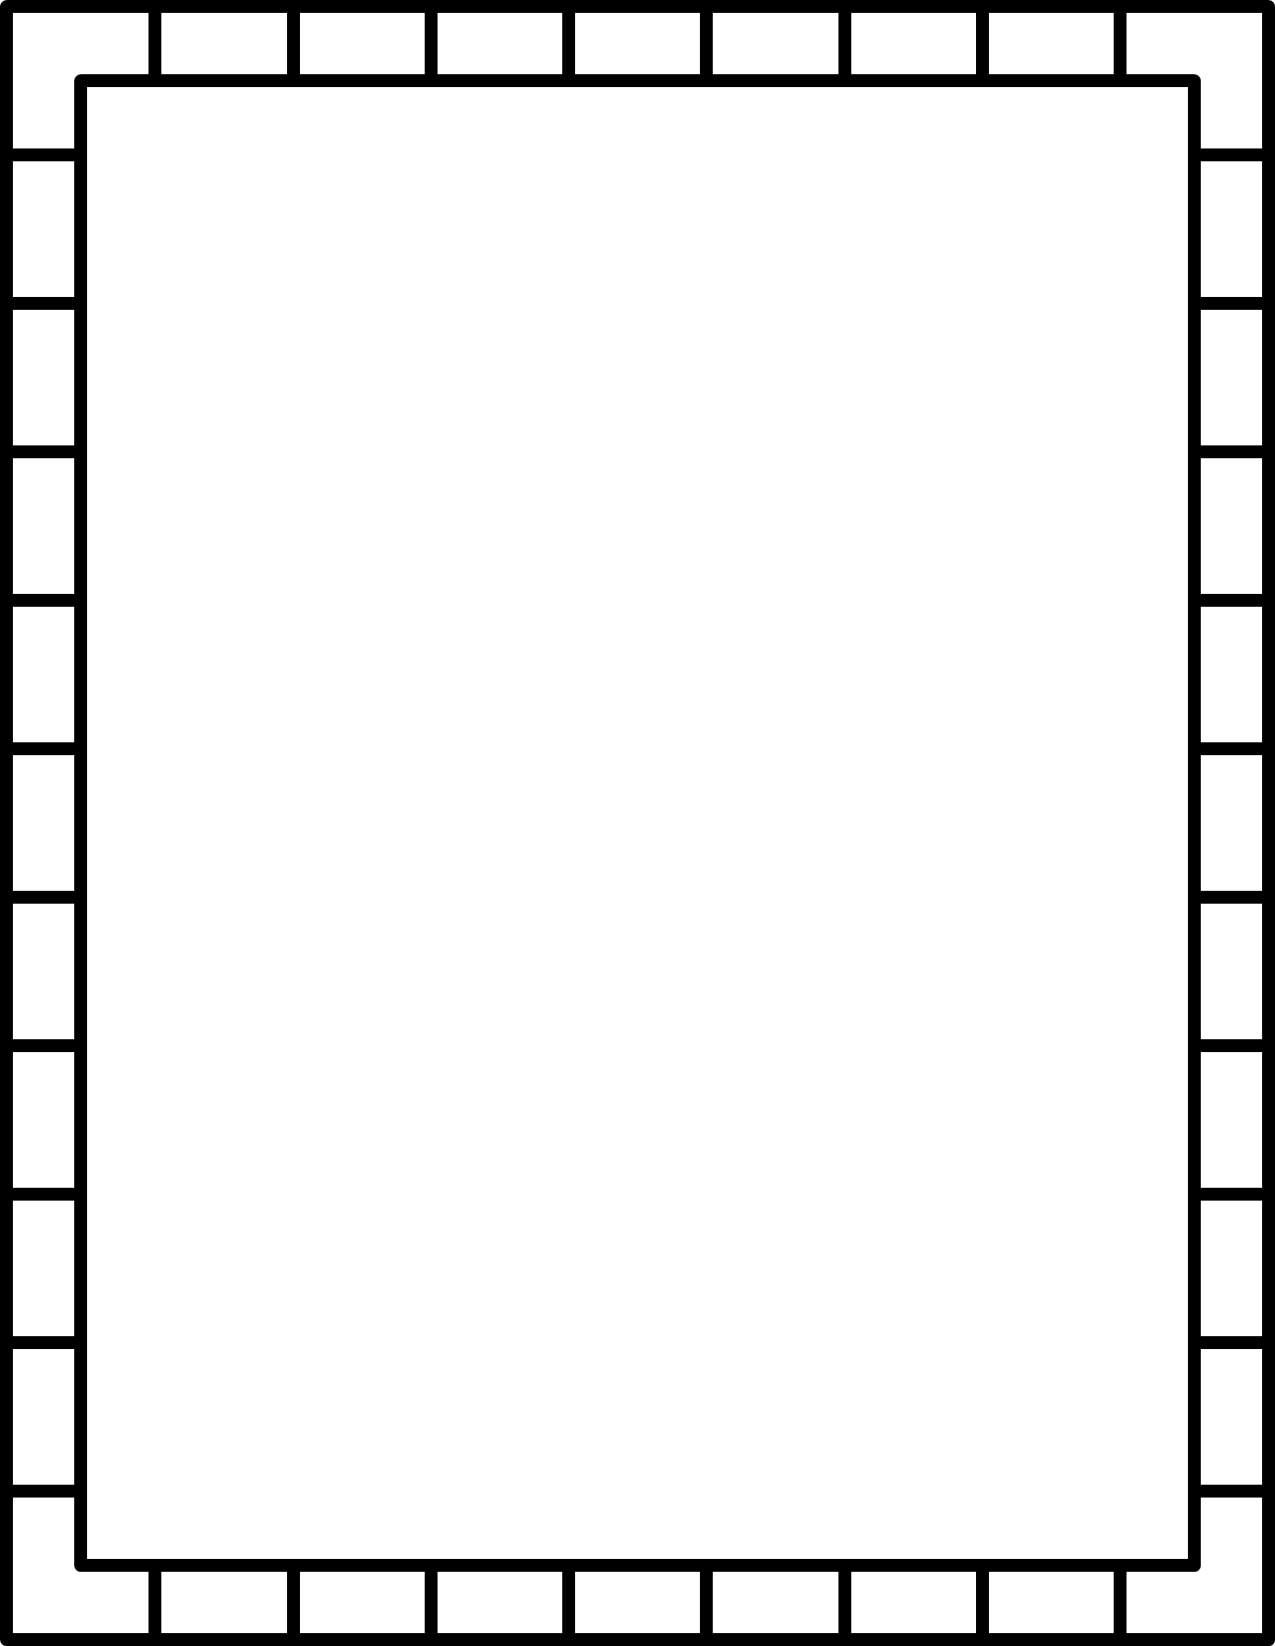
Mathematics

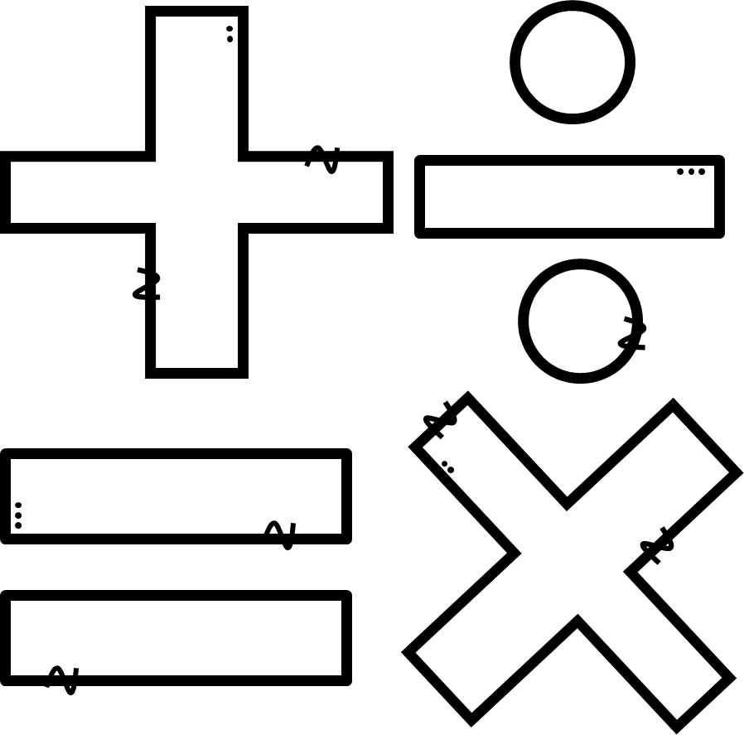
Name: ________________
Grade: 3.2
S. Sparrius
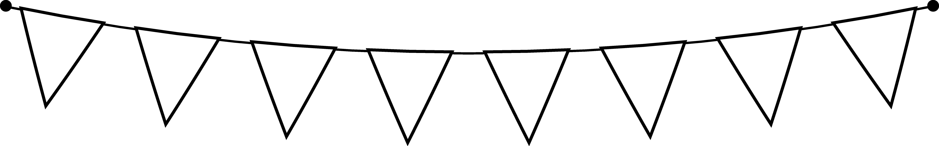

Naam: ________________
Graad: 3.2
S. Sparrius

oe
ou
ei
ui
Afrikaans
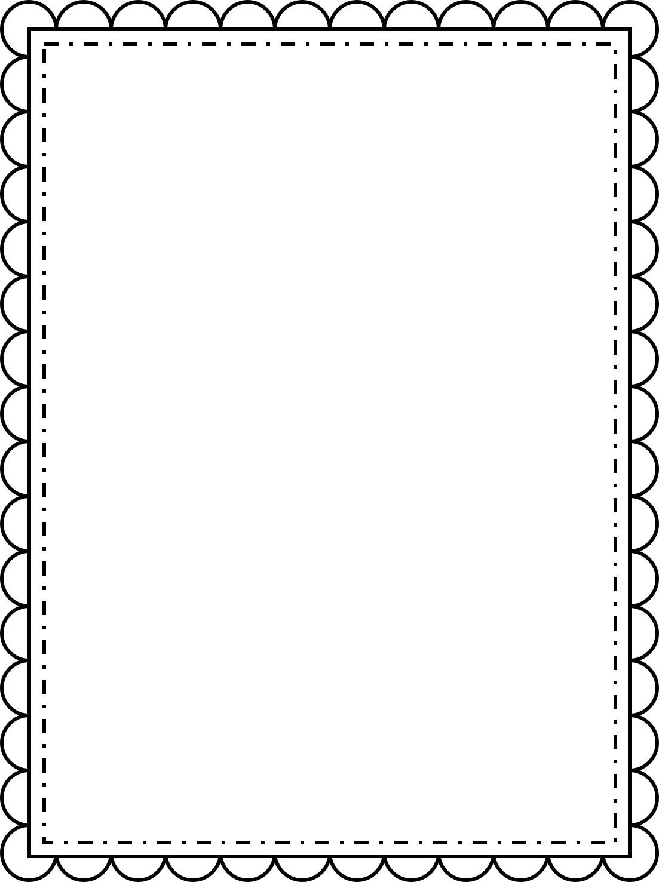
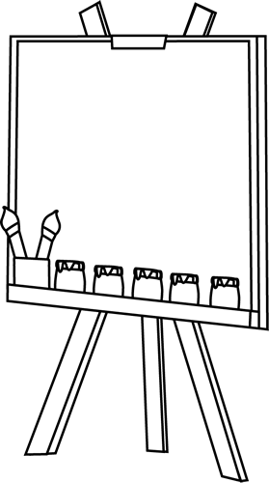
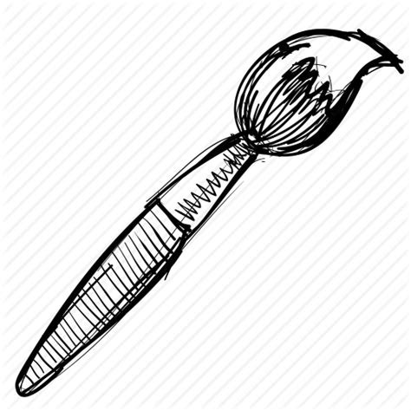
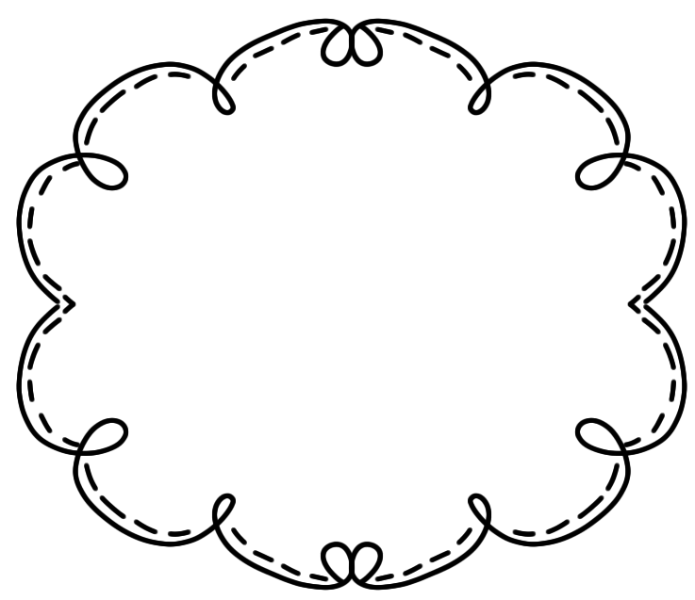
Name: ________________
Grade: 3.2
S. Sparrius
Art
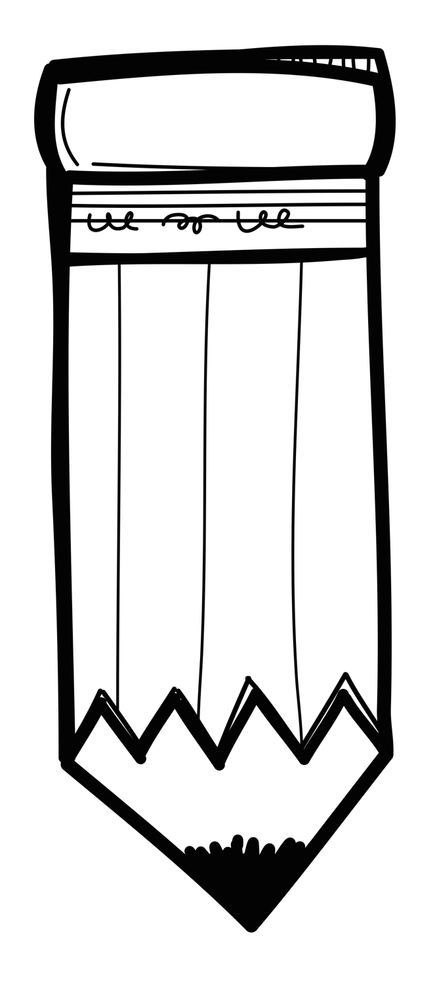

Skrif
Naam: ________________
Graad: 3.2
S. Sparrius
koei
leeu
leeu
saai
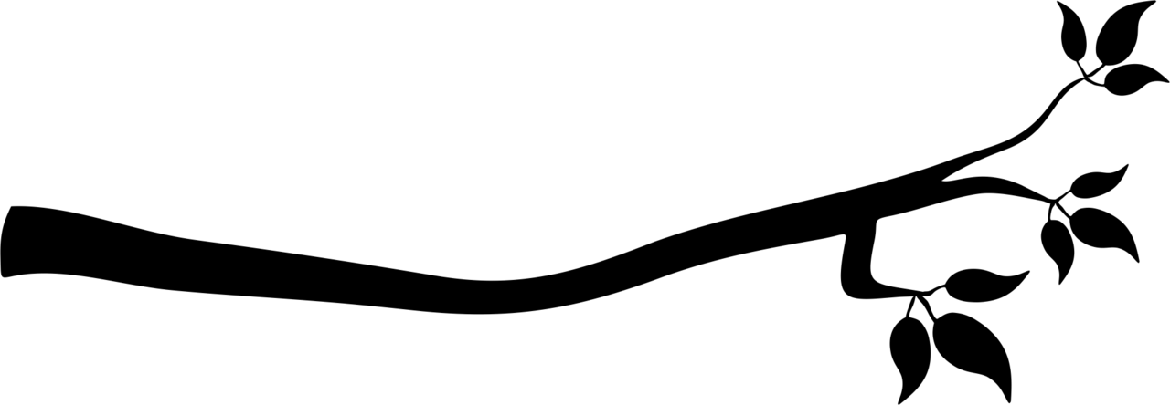

Name: ________________
Grade: 3.2
S. Sparrius
Classwork book

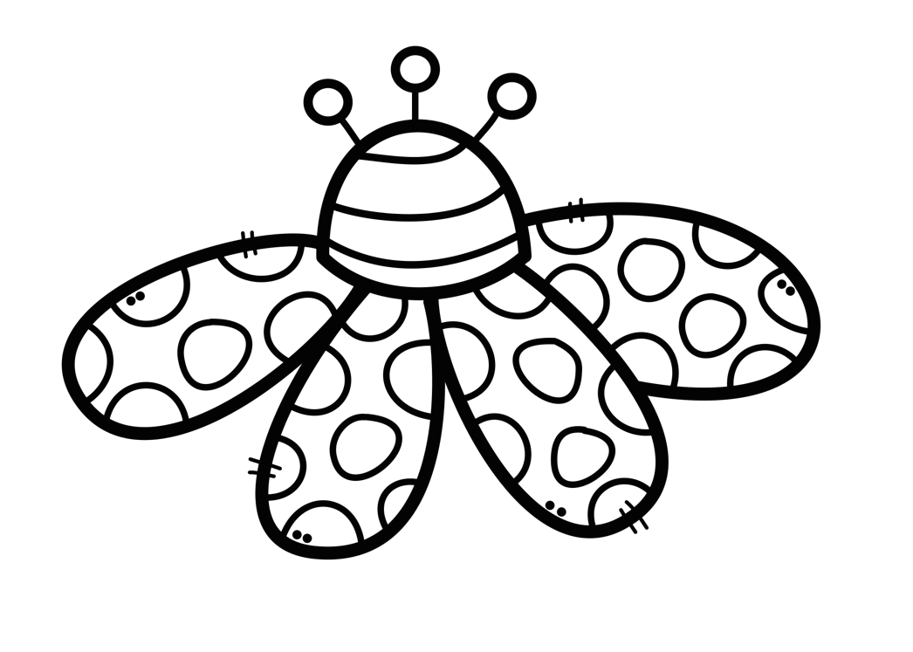

Test book
Name: ________________
Grade: 3.2
S. Sparrius
Do your
best!

Name: ________________
Grade: 3.2
S. Sparrius

chin
shark
shell
chair
English

Skrif
Naam: ________________
Graad: 3.2
S. Sparrius
/koei
leeu
/leeu
/saai

