First Additional Language
Assessment Term 4
Grade 3

Name and Surname: ____________________________
Date: _________________________________

Content |  | Mark
- Listening and speaking | 30
- Reading | 25
- Phonics | 25
- Writing and handwriting | 20
Total | 100

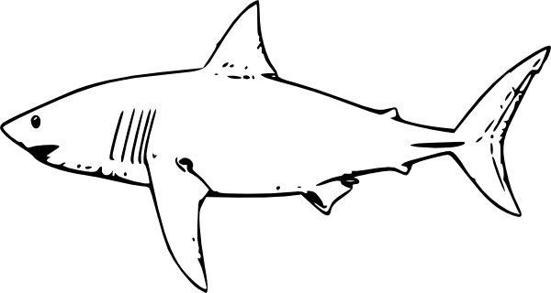
Activity 1
Listening and speaking: Part 1
Marks: 20

  - Listening Comprehension
Listen to the story while the teacher is reading and answer comprehension questions orally. You will be marked according to a rubric.
Sharks
What has fins, sharp teeth, and swims in the ocean? A shark!

Sharks have been around for a very long time. Sharks have lived in the oceans even before dinosaurs roamed the earth! Sharks are fish, and there are over 400 types of sharks. When they have babies, the babies are called pups.

Sharks lose their teeth, like humans, but they don’t just lose their baby teeth. They lose teeth throughout their lives. When a shark loses a tooth, a tooth from another row of teeth will move into its place. New teeth are always growing. Most sharks are carnivores, so they feed on other animals, like fish or seals.

Sharks might look scary, but they are not usually dangerous to people. People are more dangerous to sharks, since people hunt sharks. To be safe, though, it is a good idea to leave sharks alone if you see them!

Answer the following questions orally:
- About what animal is the story?
- Name three things which they tell us at the beginning of the story by which a shark is known for.
- How many types of sharks are there?
- What is the babies of sharks called?
- What do sharks eat? Name two things.
- What happens when a shark loses its teeth?
- Why do you think people hunt sharks?

Listening and Speaking Rubric
 | 1 | 2 | 3 | 4
Vocabulary and language use | Struggles to communicate effectively, limited vocabulary. Cannot print himself / herself. | Uses a limited vocabulary. Makes many grammatical errors. | Uses appropriate vocabulary. Talks in full sentences and speaks in the correct time, eg. Past, future or present. | Uses a comprehensive vocabulary. Talks in full sentences and uses correct and good language. Use descriptive words.
Appropriate volume and intonation | Talks too soft or mumbles. Difficult to understand and hear. | Talks too fast. Sometimes difficult to understand. | Talk slowly and clearly. Easy to understand. Most of the time can be clearly heard. | Talk slowly and clearly. Can be easily heard and understood at all times.
Content | Learner doesn’t participate. Doesn’t want to try to answer questions. | Limited content. Teacher must ask questions to get clarity. | Spontaneous. Provides adequate content which is expected of the learner. | Spontaneous and elaborative. Content provides more information than expected.
Comprehension skills | Most of the answers to the questions are incorrect. | Some of the answers are correct. | Most of the answers are correct. | All of the answers were correct. The learner was able to answer in full sentences.
Ask questions for clarity | The learner has to ask questions the whole time for clarity because he seldom gives attention when given instructions. | The learner has to ask questions some times for clarity because he seldom gives attention when given instructions. | The learner has to ask questions seldom for clarity because he gives attention when instructions are given. | The learner never has to ask questions for clarity because he gives attention when instructions are given.
 |  |  | Total /20

Listening and Speaking: Part 2
Marks: 10

Instructions:
Retell the story about the shark which your teacher has read to you in 3 sentences.

You will be assessed according to the following rubric:

Rubric : Retelling of story |  | Mark obtained
- Was the learner able to shortly retell wat happened in the story? | 5
- Learner speaks clearly and pronounces words correct. | 1
- The learner speaks with confidence and makes eye contact and uses facial expressions. | 4
Total | 10
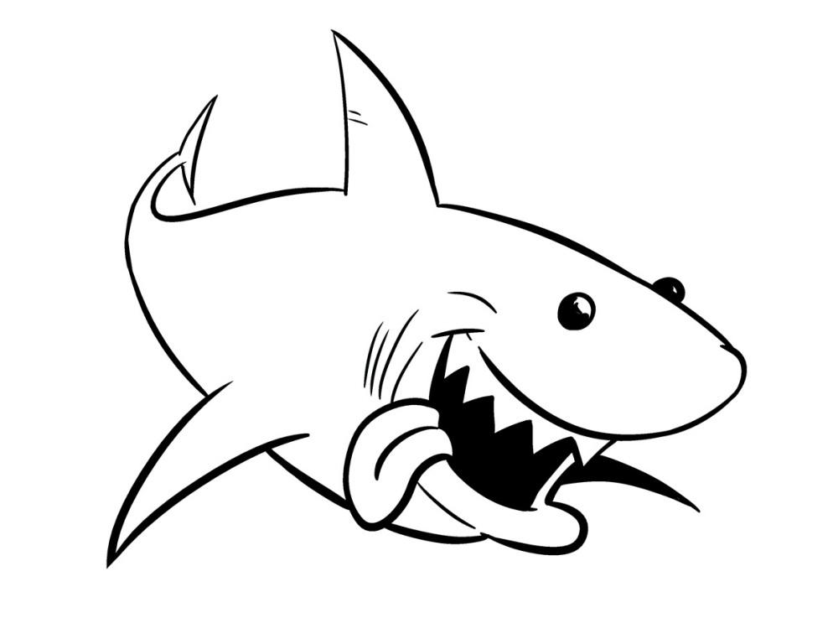

Activity 2
Reading
Marks: 25

2.1. Shared reading – Comprehension test.
Read shark tales below and answer the questions.
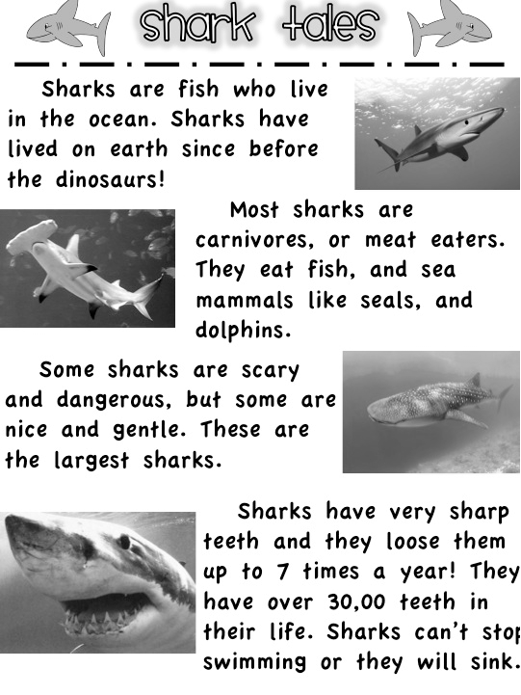

- Since when have sharks lived on the earth?
___________________________________________________________________________________________(1)

- What is a carnivore?
_____________________________________________(1)

- What do sharks eat?
___________________________________________________________________________________________(3)

- How many times do sharks lose their teeth?
_____________________________________________(1)

- How many teeth do they have?
_____________________________________________(1)

- Why can’t a shark stop swimming?
___________________________________________________________________________________________(1)

- Make a sentence with the word sharp.
___________________________________________________________________________________________(1)

- Make a sentence with the word sink.
___________________________________________________________________________________________(1)

Total: __/10
2.2. Group Guided Reading

Read aloud from your own book in a guided reading group with the teacher. This means the whole group reads the same story or non-fiction text with the teacher. You will be marked according to this rubric:

Rubric – Group Guided Reading
- Words a pronounced correctly. | 2
- Learner makes use of the reading strategies taught in the Home Language to make sense and monitor self when reading (phonics, context clues, structural analysis, sight words) | 2
- Learner reads with increasing fluency and expression. | 2
- Shows an understanding of punctuation when reading aloud. | 2
- Reads with feeling and intonation. | 2
Total | 10

2.3. Independent reading – Read the paragraph below
aloud to your Teacher.

Sharks
What has fins, sharp teeth, and swims in the ocean? A shark!

Sharks have been around for a very long time. Sharks have lived in the oceans even before dinosaurs roamed the earth! Sharks are fish, and there are over 400 types of sharks. When they have babies, the babies are called pups.

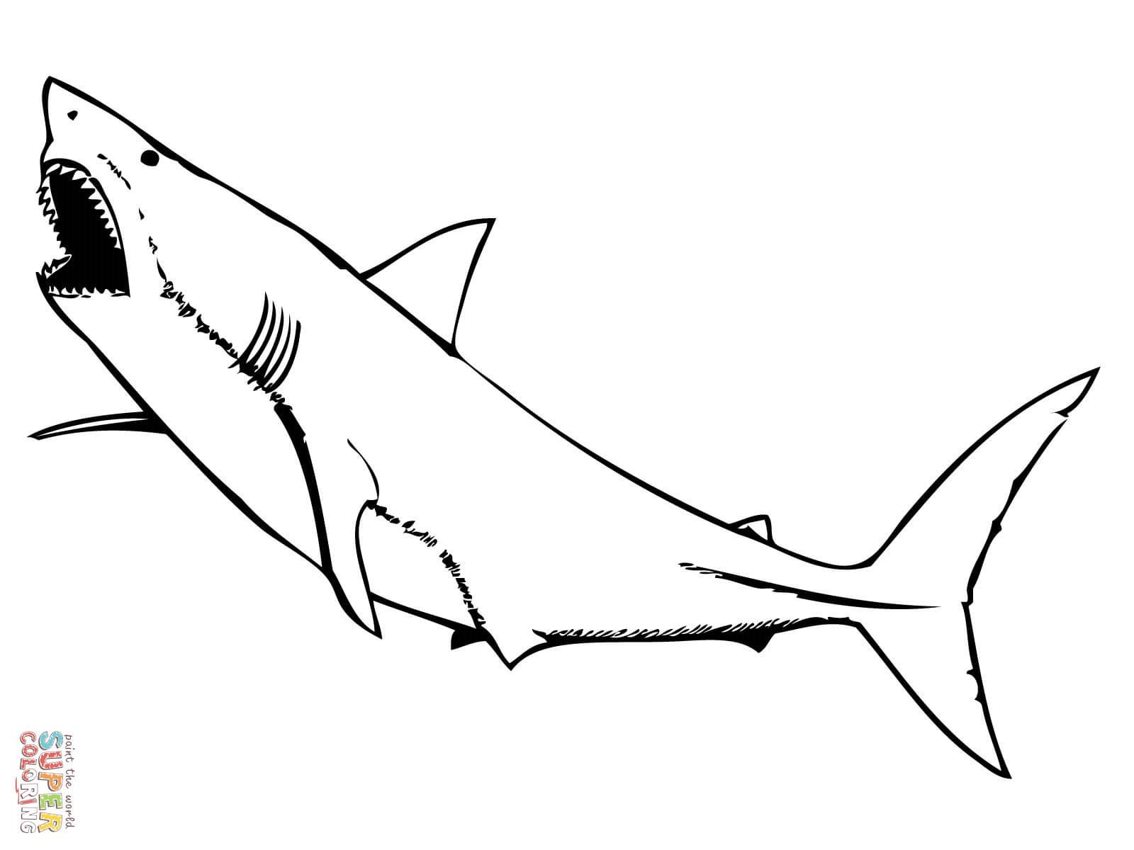

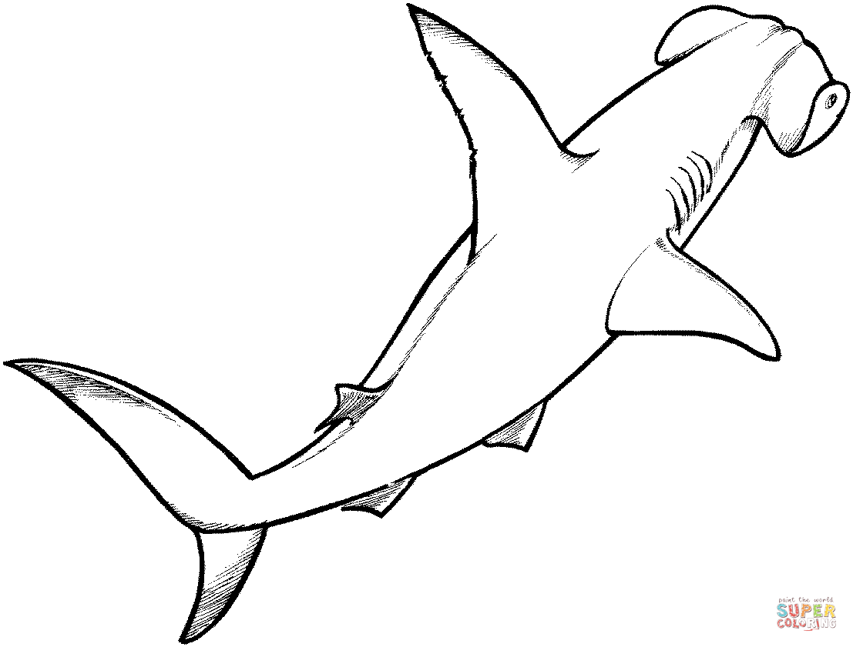

Rubric – Independent reading
- Words a pronounced correctly. | 2
- Learner makes use of the reading strategies taught in the Home Language to make sense and monitor self when reading (phonics, context clues, structural analysis, sight words) | 2
- Learner reads with increasing fluency and expression. | 2
- Shows an understanding of punctuation when reading aloud. | 2
- Reads with feeling and intonation. | 2
Total | 10

Total Independent reading (10 x ƒ = 5) = _____/5
Activity 3
Phonics
Marks: 25

  - Read the poem and underline all the words which rhymes with a pencil. (8 x ƒ = 4)
When I have a bad dream,
I give a loud scream.
I had a dream about my rugby team,
being thrown with ice-cream.

We lost the rugby match,
because we could not catch.
The team was very sad,
and also a little mad.

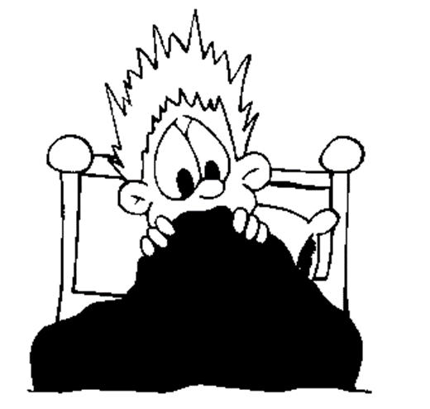

  - Write your own words in the table using the vowel digraphs. (8 x ƒ = 4)
ar- | er- | ir- | ur-

  - Complete the following sentences by using the pronouns word in the block. (5)
his its your her
their our my

- They ate ____________ supper.
- She did _________ homework.
- He tidied _________ room.
- We did __________ homework.
- You must tidy _________ room.

  - Build a new word by using the following suffixes. (5)
Suffix | New word
-es
-ies
-ly
-ing
-ed

  - Write down the plural of the following words. (2 x ƒ = 1)
Singular | Plural
cherry
baby

  - Write the opposite meaning of the word. (2)
    - pretty - _____________
    - bad - ___________

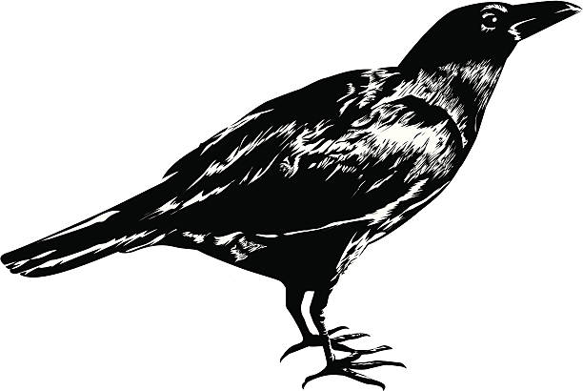
  - Complete the words. (4)
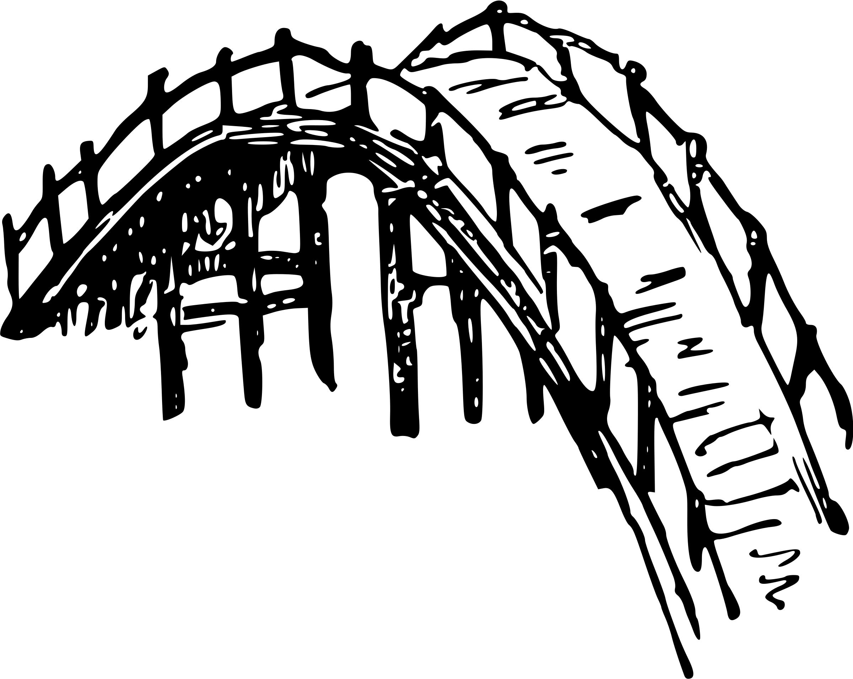
    - _ _ ow
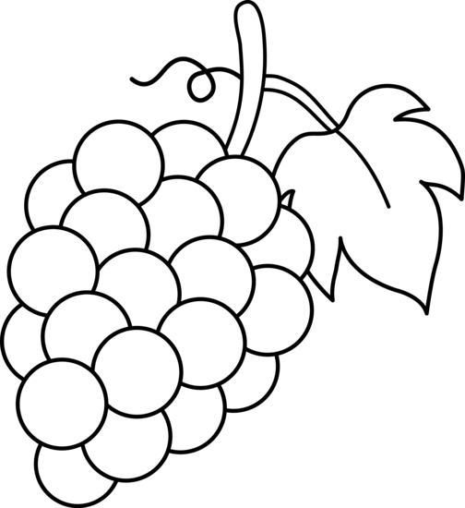
    - _ _ idge
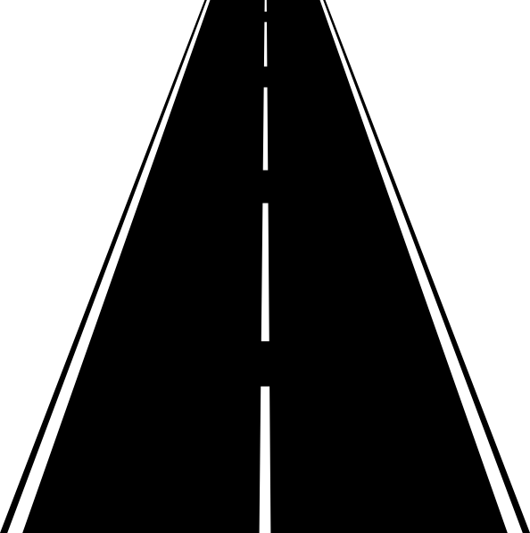
    - _ _ apes
    - _ _ _ eet

Total Activity 3: ___/25
Activity 4
Writing and Handwriting
Marks: 20

Write a list with headings in the block below. Choose between one of the following topics:
- Transport.
- Food which comes directly from the ground.
- Animals who help us.

Rubric – Writing and Handwriting (List with heading) | 1 | 2 | 3 | 4 | 5
- List with heading: Did the learner write a list with a heading. | No attempt of list with heading. | Poor attempt of list with heading. | Average list with heading. | List with heading is good. | Outstanding list with heading.
- Letter formation-  Did the learner form his letters correctly? | Many errors in letter formation. Incorrect letter formations. | Some errors in letter formation. Letters formed incorrectly. | Few errors in letter formation. Few letters are formed incorrectly. | Most letters are formed correctly. | Consistently forms all letters correctly.
- Readability – How easy is it to read the learners handwriting? | Many errors in readability. | Some errors in readability. | Few errors in readability. | Very easy to read. | Always easy to read.
- Neatness - How neat is the learners handwriting? | Difficult to read. | Not neatly done. | Not as neatly done. | Writes neatly. | Always writes neatly.
Total: ___/20

