**First Additional Language**

**Assessment Term 3**

**Grade 3**

**Name and Surname: ____________________________**

**Date: _________________________________**

**MEMORANDUM**

|  |  |  |
| --- | --- | --- |
| **Content** |  | **Mark** |
| 1. Listening and speaking | **30** |  |
| 1. Reading | **30** |  |
| 1. Phonics | **30** |  |
| 1. Writing and handwriting | **20** |  |
| **Total** | **110** |  |

Activity 1

Listening and speaking

Marks: 20

* 1. Listening Comprehension

Listen to the story while the teacher is reading and answer comprehension questions orally.

The lives of turtles

There are about 250 kinds of turtles. Most turtles live near fresh water. They spend part of their time swimming in the water and part of it on land.

**Tortoises**: Tortoises are slow and steady. They have short, thick back legs. Their flat front legs are built like shovels and are very good for digging. Tortoises have high, rounded shells, too. Many tortoises can pull their heads, legs, and tails inside their shells. They quickly do so at any sign of danger. Their strong shells protect them from animals that might want to eat them.

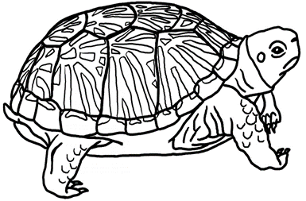

Answer the following questions orally:

1. **About what animal is the story? (1)**

The story is about turtles.

1. **How many kinds of turtles are there? (1)**

There is 250 kinds of turtles.

1. **Where does turtles live? (3)**

Turtles lives near fresh water. They spend part of their time swimming in the water and part of it on land.

1. **Are tortoises fast or slow? (1)**

Turtles are very slow.

1. **How is a tortoises front legs build and what do they use their front legs for? (2)**

Their flat front legs are built like shovels and are very good for digging.

1. **Why does a turtle pull themselves into their shell? (2)**

They climb into their shells at any sign of danger. Their strong shells protect them from animals that might want to eat them.

√

√

√

√

√

√

√

|  |  |  |  |  |
| --- | --- | --- | --- | --- |
| **Listening and Speaking Rubric** | | | | |
|  | **1** | **2** | **3** | **4** |
| **Vocabulary and language use** | Struggles to communicate effectively, limited vocabulary. Cannot print himself / herself. | Uses a limited vocabulary. Makes many grammatical errors. | Uses appropriate vocabulary. Talks in full sentences and speaks in the correct time, eg. Past, future or present. | Uses a comprehensive vocabulary. Talks in full sentences and uses correct and good language. Use descriptive words. |
| **Appropriate volume and intonation** | Talks too soft or mumbles. Difficult to understand and hear. | Talks too fast. Sometimes difficult to understand. | Talk slowly and clearly. Easy to understand. Most of the time can be clearly heard. | Talk slowly and clearly. Can be easily heard and understood at all times. |
| **Content** | Learner doesn’t participate. Doesn’t want to try to answer questions. | Limited content. Teacher must ask questions to get clarity. | Spontaneous. Provides adequate content which is expected of the learner. | Spontaneous and elaborative. Content provides more information than expected. |
| **Comprehension skills** | Most of the answers to the questions are incorrect. | Some of the answers are correct. | Most of the answers are correct. | All of the answers were correct. The learner was able to answer in full sentences. |
| **Ask questions for clarity** | The learner has to ask questions the **whole time** for clarity because he seldom gives attention when given instructions. | The learner has to ask questions **some times** for clarity because he seldom gives attention when given instructions. | The learner has to ask questions **seldom** for clarity because he gives attention when instructions are given. | The learner **never** has to ask questions for clarity because he gives attention when instructions are given. |
|  | | | **Total /20** |  |

**Listening activity**

Listen to the instructions of the teacher and concentrate. Do exactly as she instructs you to do. Remember to draw neatly.

Mark allocation questions 3:

√ for pattern and √ for

only in ONE shape.

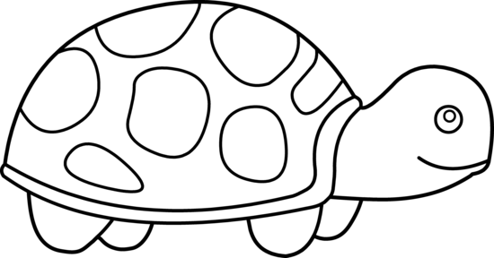

brown

brown

Mark allocation

questions 4:

√ for brown

and √ for

TWO shapes colored in

brown.

blue

patterns

green

Mark allocation

questions 1:

√ for head green.

√ for legs green.

green

green

Turtle’s name: Childs own creativity

**Instructions:**

1. Color the turtles head and legs green. (2)
2. Color the turtles eyes blue. (1)
3. Draw patterns inside the ONE of shapes on the turtles shell. (2)
4. Color TWO of the shapes on the turtles shell brown. (2)
5. Draw a sun in the top right side corner of the block. (1)
6. Color the sun yellow. (1)
7. Write a name of the turtle on the line. (1)

Total: ______ / 10

**Activity 2**

**Reading**

**Marks: 30**

2.1. Shared reading – Comprehension test.

Read the comic newspaper article and answer the questions.

Remember to answer in full sentences and with the

correct punctuation.

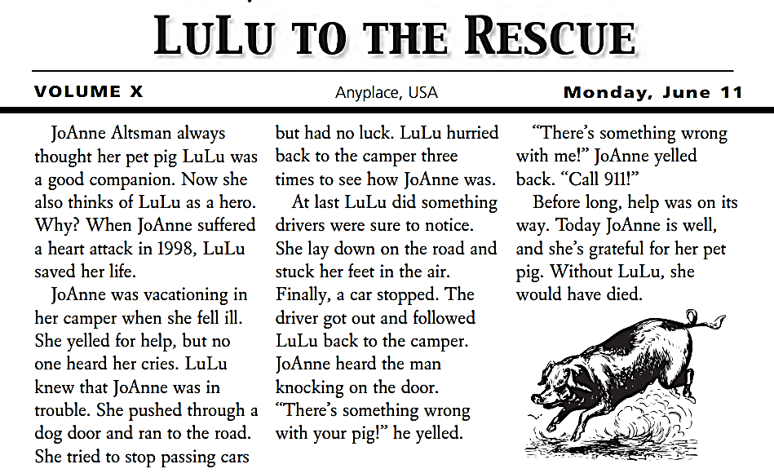

1. **On which date was this newspaper article written?**

√

√

The newspaper article was written on Monday, 11 June. (2)

1. **What is the heading of the newspaper article?**

√

LuLu to the rescue. (1)

1. **What is the name of JoAnne Altsman’s pet pig?**

√

The pigs name is LuLu. (1)

1. **What happened to JoAnne in 1998?**

√

JoAnne suffered from a hart attack in 1998. (1)

1. **Why does JoAnne think of LuLu as a hero?**

√

JoAnne thinks LuLu is a hero because LuLu saved her life. (1)

1. **How dit LuLu save JoAnne’s life? Write 3 things down which LuLu dit to save her life. (3)**

* LuLu knew JoAnne was in trouble so she pushed through the dog door and ran to the road.
* She then went and lay down in the road to get attention.
* She let the driver from the car follow her back to where JoAnne was.

1. LuLu was a good companion.” What is a companion? Circle the correct answer. (1)

* guard
* doctor
* nurse
* friend

Total: ___/10

2.2. Group Guided Reading

Read aloud from your own book in a guided reading group with the teacher. This means the whole group reads the same story or non-fiction text with the teacher. You will be marked according to this rubric:

|  |  |  |
| --- | --- | --- |
| **Rubric – Group Guided Reading** |  |  |
| 1. Words a pronounced correctly. | **2** |  |
| 1. Learner makes use of the reading strategies taught in the Home Language to make sense and monitor self when reading (phonics, context clues, structural analysis, sight words) | **2** |  |
| 1. Learner reads with increasing fluency and expression. | **2** |  |
| 1. Shows an understanding of punctuation when reading aloud. | **2** |  |
| 1. Reads with feeling and intonation. | **2** |  |
| **Total** | **10** |  |

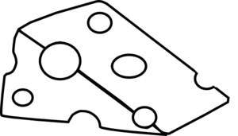2.3. Independent reading – Read the story below aloud

to your Teacher.

**The hungry mouse**

A mouse was having a very bad time. She could find no food at all. She looked here and there, but there was no food, and she grew very thin. At last the mouse found a basket, full of corn. There was a small hole in the basket, and she crept in. She could just get through the hole.

Then she began to eat the corn. Being very hungry, she ate a great deal, and went on eating and eating. She had grown very fat before she felt that she had had enough. When the mouse tried to climb out of the basket, she could not. She was too fat to pass through the hole.

"How shall I climb out?" said the mouse.

"Oh, how shall I climb out?"  
Just then a rat came along, and he heard the mouse.

"Mouse," said the rat, "if you want to climb out of the basket, you must wait till you have grown as thin as you were when you went in." 

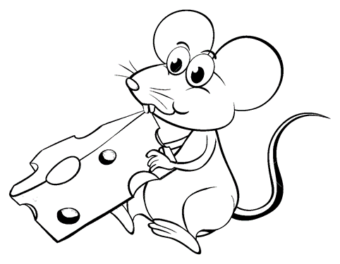

|  |  |  |
| --- | --- | --- |
| **Rubric – Independent reading** |  |  |
| 1. Words a pronounced correctly. | **2** |  |
| 1. Learner makes use of the reading strategies taught in the Home Language to make sense and monitor self when reading (phonics, context clues, structural analysis, sight words) | **2** |  |
| 1. Learner reads with increasing fluency and expression. | **2** |  |
| 1. Shows an understanding of punctuation when reading aloud. | **2** |  |
| 1. Reads with feeling and intonation. | **2** |  |
| **Total** | **10** |  |

**Activity 3**

**Phonics**

**Marks: 30**

* 1. Choose the best consonant digraphs in the box and complete the words in each sentence. (5)

|  |  |  |  |
| --- | --- | --- | --- |
| ph | ll | ss | ff |

ll

1. I picked up a shiny she__ on the beach.

ph

1. The __one has rung at least ten times today.

ff

1. The sta__ at the shopping center was very helpful.

ff

1. The policeman put a handcu__ around the robber’s hands.

ss

1. My dad gave my mom a ki__ on the cheek.
   1. Write your own words in the table using the consonant blends. (8)

|  |  |  |  |
| --- | --- | --- | --- |
| **str-** | **scr-** | **tch-** | **nch-** |
| string | screw | watch | punch |
| strong | screen | catch | lunch |
| street | scream | switch | bench |
| stranger | scratch | stretch | branch |

Enige ander korrekte antwoord van leerder kan aanvaar word.

* 1. Underline the word which is not spelled correctly in the following sentences. (5)

1. The man broke his leg and now he is in a lot of payn/pain.
2. The girl paid her ice cream with a coin/coyn.
3. My brother’s favorite toi/toy is his firetruck.
4. The circle is round/roundt.
5. I bumped my haid/head into the wall.
   1. Complete the following sentences by using **this**, **those** and **these**. (4)

This

1. ______ is my hat.

Those

1. ______ are my friends outside.

Those

1. ______ belong to my teacher.

These

1. ______ are not mine.
   1. Write down the plurals of the following words in die table. (4)

|  |  |  |  |
| --- | --- | --- | --- |
| chair | **chairs** | brush | **brushes** |
| bus | **busses** | tooth | **teeth** |

* 1. Draw a line to match the words with their opposite meaning. (4)

|  |  |  |
| --- | --- | --- |
| bad |  | thin |
| pretty | sad |
| fat | good |
| happy | ugly |

**Activity 4**

**Writing and Handwriting**

**Marks: 20**

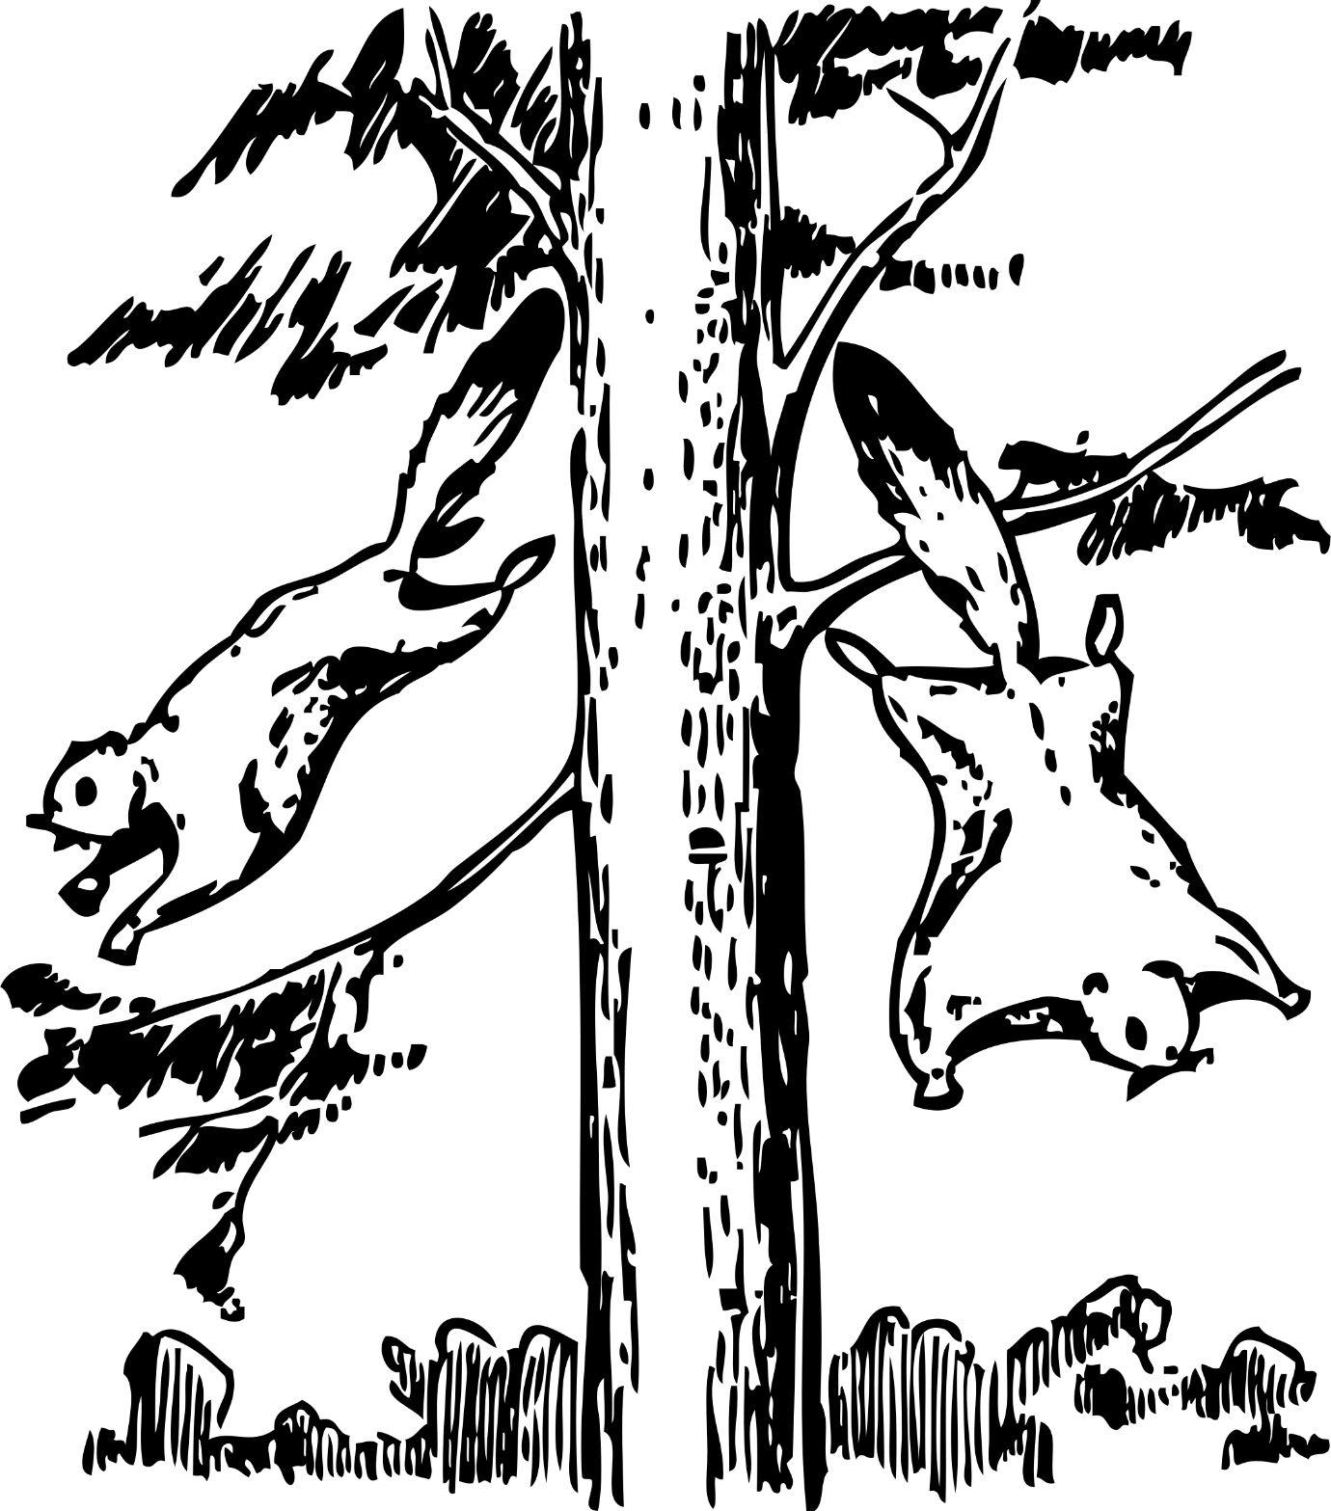Write the following paragraph over on the lines in cursive writing.

When a flying squirrel wants to get from a high tree branch to a lower one, it leaps into the air with its four legs spread wide apart. Flaps of skin between its front and back legs act like a parachute to slow the squirrel’s fall.

_______________________________________________________________________________________________________________________________________________________________________________________________________________________________________________________________________________________________________________________________________________________________________________________________________________________________________________________________________________________________________________________________________________________________________________________________________________________________________________________________________________________________________________________________________________________________________________________________________________________________________________________________________________________________________________________________________________________________________________________________________________________________________________________________________________________________________________________________________________________________________________________________

|  |  |  |  |  |  |
| --- | --- | --- | --- | --- | --- |
| **Rubric – Writing and Handwriting: Cursive** | 1 | 2 | 3 | 4 | 5 |
| 1. Line usage – How well did the learner use his writing lines? | Many errors in line usage. | Some errors in line usage. | Few errors using lines correctly. | Uses lines correctly most of the time. | Always uses lines correctly. |
| 1. Spacing - How well did the learner space their letters and/or words? | Many errors in spacing. | Some errors in spacing. | Few errors using spacing correctly. | Uses proper spacing most of the time. | Always uses proper spacing. |
| 1. Letter formation-   Did the learner form his letters correctly? | Many errors in letter formation. Incorrect letter formations**.** | Some errors in letter formation. Letters formed incorrectly. | Few errors in letter formation. Few letters are formed incorrectly. | Most letters are formed correctly. | Consistently forms all letters correctly. |
| 1. Readability – How easy is it to read the learners handwriting? | Many errors in readability. | Some errors in readability. | Few errors in readability. | Very easy to read. | Always easy to read. |
| 1. Neatness - How neat is the learners handwriting? | Difficult to read. | Not neatly done. | Not as neatly done. | Writes neatly. | Always writes neatly. |
|  |  |  |  |  |  |
| Total: ___/20 | | | | | |