**English First Additional Language**

**Assessment Term 4**

**Grade 1**

**Name and Surname: ____________________________**

**Date: _________________________________**

|  |  |  |
| --- | --- | --- |
| **Content** |  | **Mark** |
| 1. Listening and speaking | **30** |  |
| 1. Reading | **30** |  |
| 1. Phonics | **30** |  |
| 1. Writing and handwriting | **20** |  |
| **Total** | **110** |  |

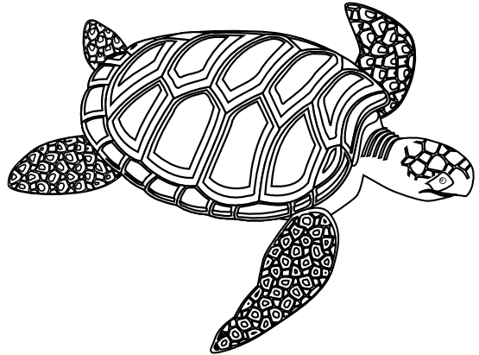Activity 1

Listening and speaking

Marks: 20

* 1. Listening Comprehension

Listen to the story while the teacher is reading and answer comprehension questions orally. You will be marked according to a rubric.

The lives of turtles

There are about 250 kinds of turtles. Most turtles live near fresh water. They spend part of their time swimming in the water and part of it on land.

**Tortoises**: Tortoises are slow. They have short, thick back legs. Their flat front legs are built like shovels and are very good for digging. Tortoises have high, rounded shells, too. Many tortoises can pull their heads, legs, and tails inside their shells. They quickly do so at any sign of danger. Their strong shells protect them from animals that might want to eat them.

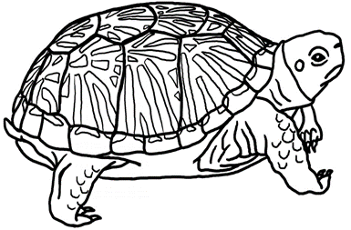

Answer the following questions orally:

1. About what animal is the story? (1)

**The story is about a tortoise.**

1. How many kinds of turtles are there? (1)

**There are 250 kinds of turtles.**

1. Where does turtles live? (2)

**They spend part of their time swimming in the water and part of it on land.**

1. Are tortoises fast or slow? (1)

**A tortoise is slow.**

1. How is a tortoises front legs build and what do they use their front legs for? (2)

**Their flat front legs are built like shovels and are very good for digging.**

1. Why does a turtle pull themselves into their shell? (2)

**They quickly pull themselves in their shells at any sign of danger. √ Their strong shells protect them from animals that might want to eat them.√**

|  |  |  |  |  |
| --- | --- | --- | --- | --- |
| **Listening and Speaking Rubric** | | | | |
|  | **1** | **2** | **3** | **4** |
| **Vocabulary and language use** | Struggles to communicate effectively, limited vocabulary. Cannot print himself / herself. | Uses a limited vocabulary. Makes many grammatical errors. | Uses appropriate vocabulary. Talks in full sentences and speaks in the correct time, eg. Past, future or present. | Uses a comprehensive vocabulary. Talks in full sentences and uses correct and good language. Use descriptive words. |
| **Appropriate volume and intonation** | Talks too soft or mumbles. Difficult to understand and hear. | Talks too fast. Sometimes difficult to understand. | Talk slowly and clearly. Easy to understand. Most of the time can be clearly heard. | Talk slowly and clearly. Can be easily heard and understood at all times. |
| **Content** | Learner doesn’t participate. Doesn’t want to try to answer questions. | Limited content. Teacher must ask questions to get clarity. | Spontaneous. Provides adequate content which is expected of the learner. | Spontaneous and elaborative. Content provides more information than expected. |
| **Comprehension skills** | Most of the answers to the questions are incorrect. | Some of the answers are correct. | Most of the answers are correct. | All of the answers were correct. The learner was able to answer in full sentences. |
| **Ask questions for clarity** | The learner has to ask questions the **whole time** for clarity because he seldom gives attention when given instructions. | The learner has to ask questions **some times** for clarity because he seldom gives attention when given instructions. | The learner has to ask questions **seldom** for clarity because he gives attention when instructions are given. | The learner **never** has to ask questions for clarity because he gives attention when instructions are given. |
|  | | | **Total /20** |  |

**Listening activity**

Listen to the instructions of the teacher and concentrate. Do exactly as she instructs you to do. Remember to draw neatly.

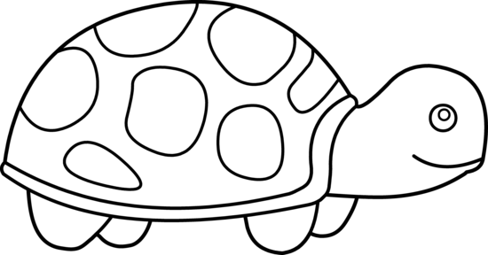

Total: ______ / 10

**Listening activity: Answer sheet**

Listen to the instructions of the teacher and concentrate. Do exactly as she instructs you to do. Remember to draw neatly.

Mark allocation questions 3:

√ for pattern and √ for

only in ONE shape.



brown

brown

Mark allocation

questions 4:

√ for brown

and √ for

TWO shapes colored in

brown.

blue

patterns

green

Mark allocation

questions 1:

√ for head green.

√ for legs green.

green

green

Turtle’s name: Childs own creativity

**Instructions:**

1. Color the turtles head and legs green. (2)
2. Color the turtles eyes blue. (1)
3. Draw patterns inside the ONE of shapes on the turtles shell. (2)
4. Color TWO of the shapes on the turtles shell brown. (2)
5. Draw a sun in the top right side corner of the block. (1)
6. Color the sun yellow. (1)
7. Write a name of the turtle on the line. (1

Total: ______ / 10

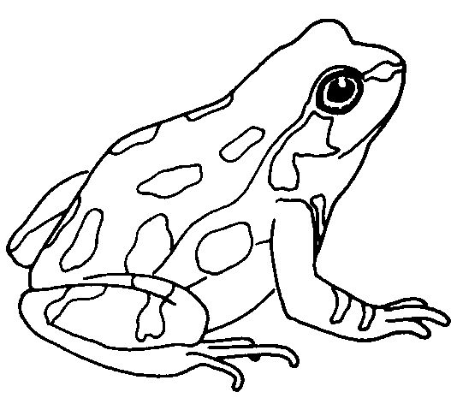**Activity 2**

**Reading**

**Marks: 30**

2.1. Shared reading – Comprehension test.

Read the story and answer the questions.

Remember to answer in full sentences and with the

correct punctuation.

**Frogs and toads**

Frogs and toads are different in many ways. Frogs spend most of their time in water. While toads spend most of their time on land. A frog’s skin is wet and smooth. A toad’s skin is dry and bumpy. Frogs have long, strong legs for leaping. Toads have shorter legs for hopping.

1. About what animals are the story about?

The story is about **frogs** and **toads**.

_____________________________________________(2)

1. Name one difference between a frog and toad? (1)

* Frogs spend most of their time in water. While toads spend most of their time on land.
* A frog’s skin is wet and smooth. A toad’s skin is dry and bumpy.
* Frogs have long, strong legs for leaping. Toads have shorter legs for hopping.

Any of the above answers are correct.

1. Circle the correct answers. (3)
   1. A toads skin is: (1)
2. Wet and smooth
3. Smooth and bumpy
4. Dry and bumpy
5. Dry and smooth.
   1. Frogs use their legs for: (1)
6. Hopping
7. Leaping
8. Walking
   1. Where does a toad live? (1)
9. Land
10. Water
11. Trees
12. Read the sentence and underline the plurals. Plural means more than one. (2)

Frogs and toads are different in many ways

1. Draw a picture where a frog and a toad live. (2)

Frog

Toad

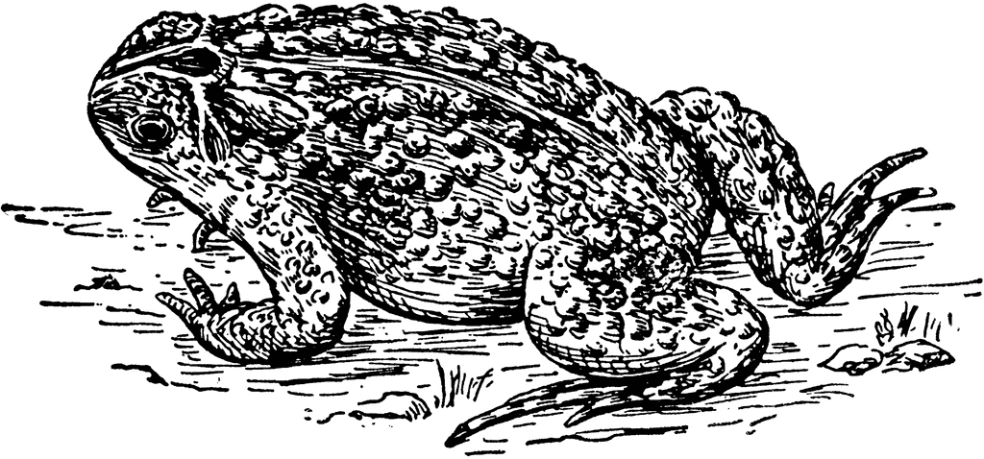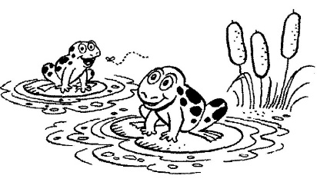

Total: __/10

2.2. Group Guided Reading

Read aloud from your own book in a guided reading group with the teacher. This means the whole group reads the same story or non-fiction text with the teacher. You will be marked according to this rubric:

|  |  |  |
| --- | --- | --- |
| **Rubric – Group Guided Reading** |  |  |
| 1. Words a pronounced correctly. | **2** |  |
| 1. Learner makes use of the reading strategies taught in the Home Language to make sense and monitor self when reading (phonics, context clues, structural analysis, sight words) | **2** |  |
| 1. Learner reads with increasing fluency and expression. | **2** |  |
| 1. Shows an understanding of punctuation when reading aloud. | **2** |  |
| 1. Reads with feeling and intonation. | **2** |  |
| **Total** | **10** |  |

2.3. Independent reading – Read the poem below aloud

to your Teacher. Remember to read with feeling.

**Colors**

Red, blue, yellow, and green.

Four bright colors to be seen.

Red is the color of the rose,

that I smell with my nose.

Blue is the color of the sky,

with fluffy clouds, way up high.

Yellow and green can be found,

on grass and flowers all around.

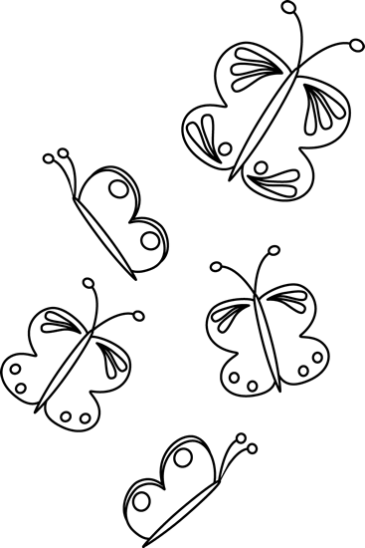

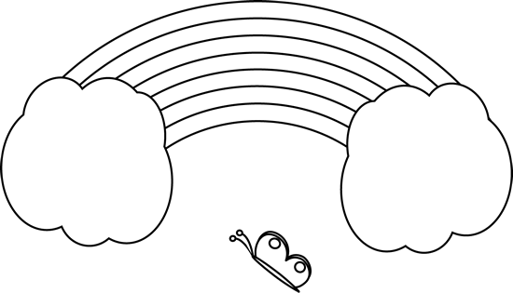

|  |  |  |
| --- | --- | --- |
| **Rubric – Independent reading** |  |  |
| 1. Words a pronounced correctly. | **2** |  |
| 1. Learner makes use of the reading strategies taught in the Home Language to make sense and monitor self when reading (phonics, context clues, structural analysis, sight words) | **2** |  |
| 1. Learner reads with increasing fluency and expression. | **2** |  |
| 1. Shows an understanding of punctuation when reading aloud. | **2** |  |
| 1. Reads with feeling and intonation. | **2** |  |
| **Total** | **10** |  |

**Activity 3**

**Phonics**

**Marks: 30**

* 1. Look at the pictures and decide if there is one or more than one. Color in the correct answer. (2)

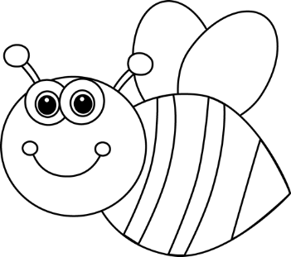

|  |  |
| --- | --- |
|  | |
| peach | peaches |

|  |  |
| --- | --- |
|  | |
| bees | bee |

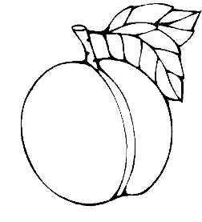

* 1. Underline the correct plural in the following sentences. (4)
     1. There are two ( bird / birds ) in the tree. (1)
     2. The boy eats a lot of ( peaches / peach). (1)
     3. The girl lost one ( shoes / shoe ). (1)
     4. There is only one ( apples / apple ) left. (1)
  2. Draw a picture that starts with the following letters. (6)

|  |  |  |
| --- | --- | --- |
| o | g  Any correct picture of the letter will be accepted as correct. | h |
| f | w | r |

* 1. Look at the pictures and color all the pictures that start with **“j ”**. (4)

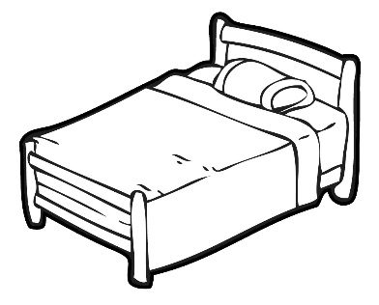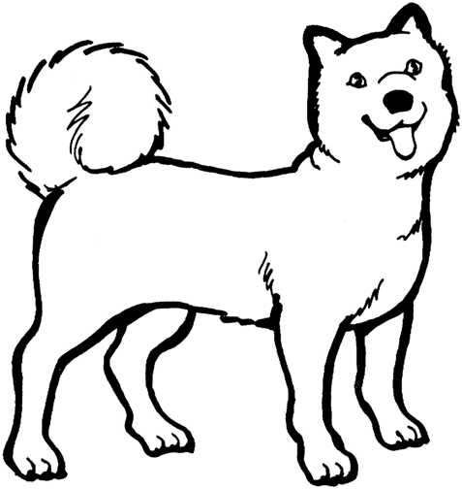

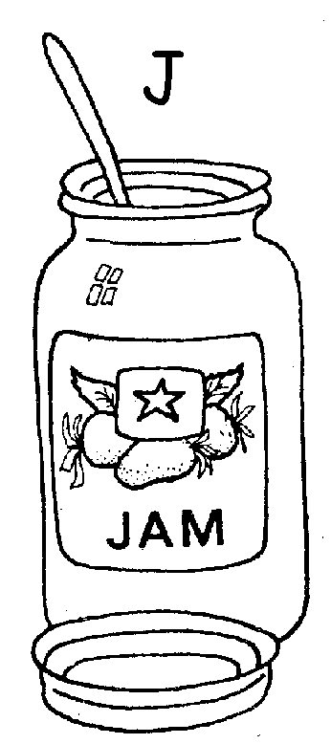

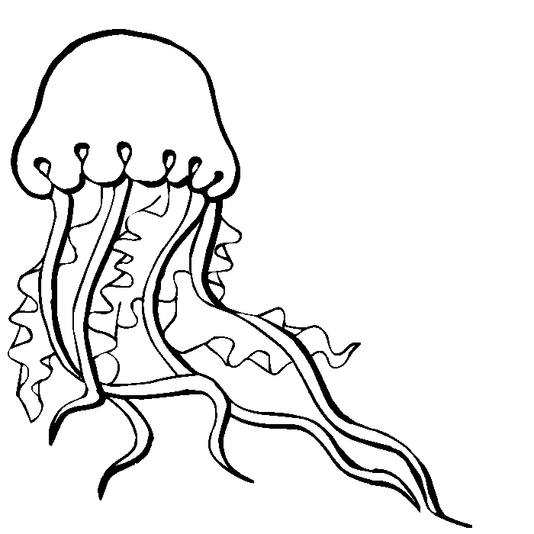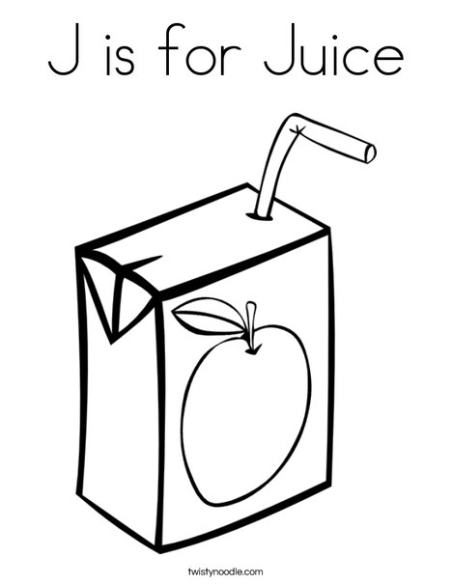

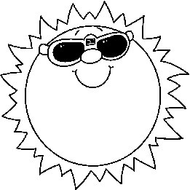

* 1. Color in the correct letter with which the word start. (6)

|  |  |  |
| --- | --- | --- |
| Image result for mouse clipart black and white  Image result for fish art black and white | Image result for knife clip art black and whiteImage result for zebra art black and white | Image result for owl art black and whiteImage result for pen clip art black and white |
|  |  |  |

* 1. Look at the pictures and fill in the correct sound. (4)

|  |  |
| --- | --- |
| Image result for glass clipart black and white  **gl** ass | Image result for fingers clipart black and white  **f** ingers |
| Image result for box clipart black and white  b **o** x | Image result for fly clipart black and white  **fl** y |

* 1. Write the opposite of the following word. (4)

|  |  |
| --- | --- |
| Black and White Elephant Looking Behind  Image result for ant clipart black and white  small _______ | Image result for car clipart black and whiteBlack and White Turtle  big  slow  fast _______ |
| Image result for moon clipart black and white  Image result for sun clipart black and white    day  ________ night | Image result for grandma clipart black and white  Image result for child clipart black and white    old  _______ young |

**Phonics total: ___/30**

**Activity 4**

**Writing and Handwriting**

**Marks: 20**

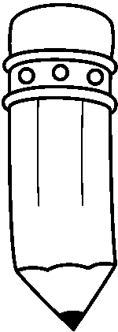

Write the following paragraph over on the lines.

Frogs and toads are different in many ways. Frogs spend most of their time in water. While toads spend most of their time on land.

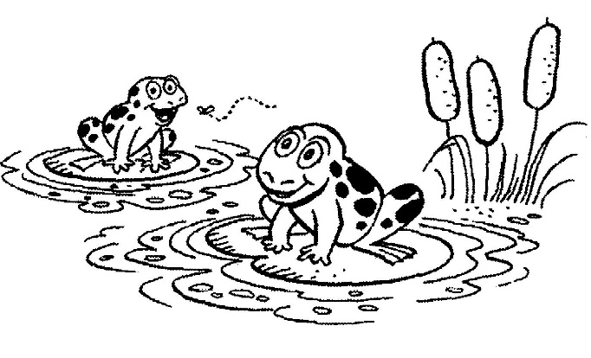________________________________________________________________________________________________________________________________________________________________________________________________________________________________________________________________________________________________________________________________________________________________________________________________________________________________________________________________________________________________________________________________________________________________________________________________________________________________________________________________________________________________________________________________

|  |  |  |  |  |  |
| --- | --- | --- | --- | --- | --- |
| **Rubric – Writing and Handwriting** | 1 | 2 | 3 | 4 | 5 |
| 1. Line usage – How well did the learner use his writing lines? | Many errors in line usage. | Some errors in line usage. | Few errors using lines correctly. | Uses lines correctly most of the time. | Always uses lines correctly. |
| 1. Spacing - How well did the learner space their letters and/or words? | Many errors in spacing. | Some errors in spacing. | Few errors using spacing correctly. | Uses proper spacing most of the time. | Always uses proper spacing. |
| 1. Letter formation-   Did the learner form his letters correctly? | Many errors in letter formation. Incorrect letter formations**.** | Some errors in letter formation. Letters formed incorrectly. | Few errors in letter formation. Few letters are formed incorrectly. | Most letters are formed correctly. | Consistently forms all letters correctly. |
| 1. Readability – How easy is it to read the learners handwriting? | Many errors in readability. | Some errors in readability. | Few errors in readability. | Very easy to read. | Always easy to read. |
| 1. Neatness - How neat is the learners handwriting? | Difficult to read. | Not neatly done. | Not as neatly done. | Writes neatly. | Always writes neatly. |
|  |  |  |  |  |  |
| Total: ___/20 | | | | | |