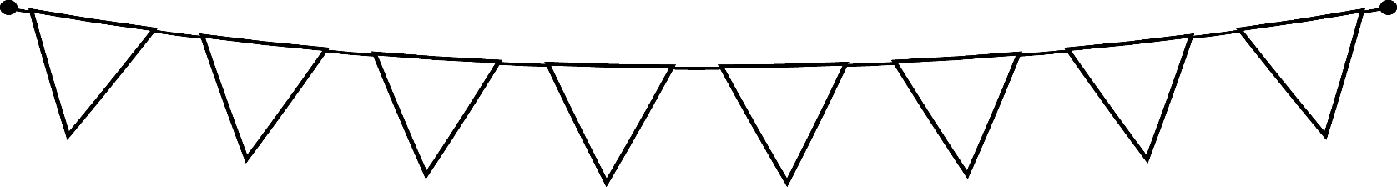

Skryf

Skryf met hulp ‘n eenvoudige stel instruksies, byvoorbeeld ‘n resep.

Skryf die stappe neer oor hoe jy ‘n grondboontjiebotter-broodjie sal maak.

Hoe om ‘n grondboontjiebotter-broodjie te maak

Wat het jy nodig?

* 2 snye brood
* Grondboontjiebotter
* Margarien
* ‘n Mes
* ‘n Bord

Hoe om ‘n grondboontjiebotter-broodjie te maak

______________________________________________________________________________________________________________________________________________________________________________________________________________________________________________________________________________________________________________________________________________________________________________________________________________________________________________________________________________________________________________________________________________________________________________________________________________________________________________________________________________________________________________________________________________________________________________________________________________________________________________________________________________________________________________________________________________________________________________________________________________________________________________________________________________________________________________________________________________________________________________________________________________________________________________________________________________________________________________________________________________________________________________________________________________________________________________________________________________________________________________________________________________________________________________________________________________________________________________________________________________________________________________________________________________________________________________________________________________________________________________________________________________________________________________________________________________________________________________________________________________________________________________________________________________________________________________________________________________________________________________________________________________________________