Sunday | Monday | Tuesday | Wednesday | Thursday | Friday | Saturday
 |  |  | 1 | 2 | 3 | 4 | Notes    ____________________________________________________________________________________________________________________________________________________________________________________________________________________________________________________________________________________________________________
5 | 6 | 7 | 8 | 9 | 10 | 11
12 | 13 | 14 | 15 | 16 | 17 | 18
19 | 20 | 21 | 22 | 23 | 24 | 25
26 | 27 | 28 | 29 | 30 | 31
January | 2020

Teacher Michelle

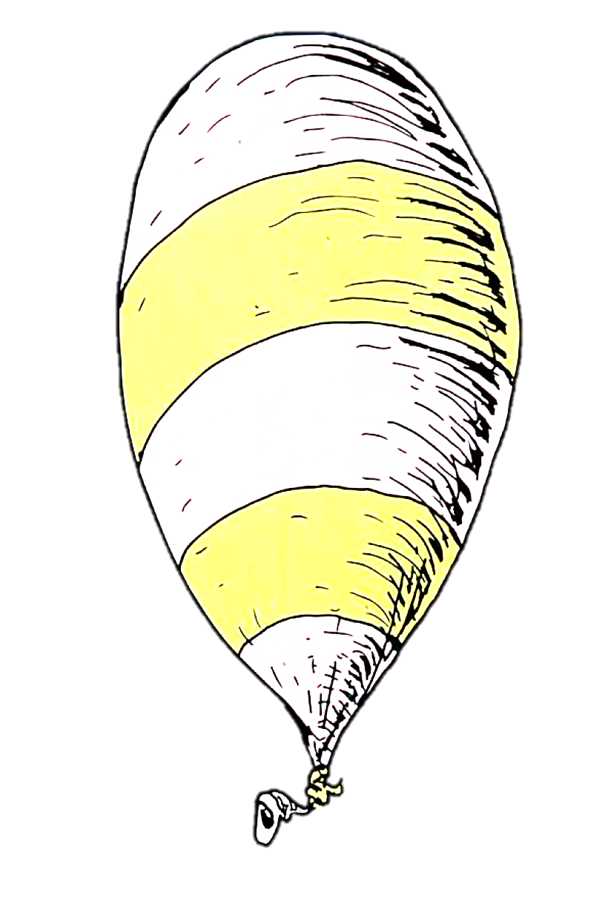
Teacher Michelle

February | 2020
Sunday | Monday | Tuesday | Wednesday | Thursday | Friday | Saturday |  |  | 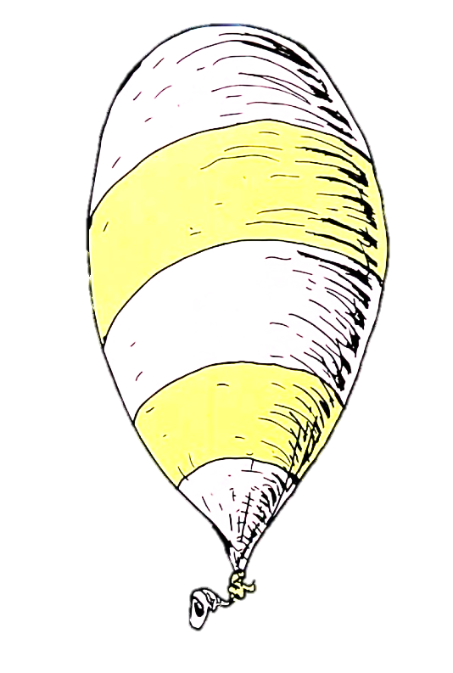
 |  |  |  |  |  | 1 | Notes  _______________________________________________________________________________________________________________________________________________________________________________________________________________  ____________________
2 | 3 | 4 | 5 | 6 | 7 | 8
9 | 10 | 11 | 12 | 13 | 14 | 15
16 | 17 | 18 | 19 | 20 | 21 | 22
 |  |  | 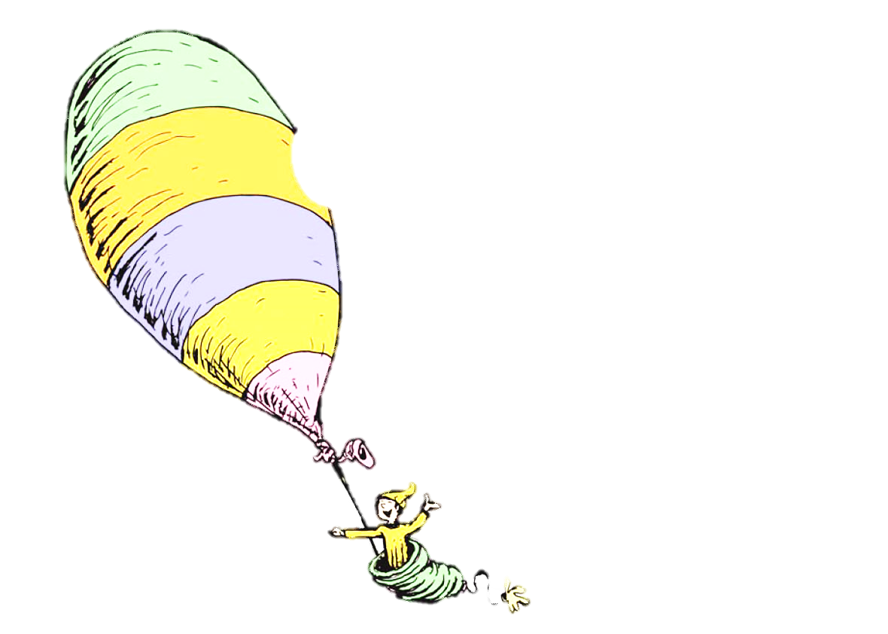
23 | 24 | 25 | 26 | 27 | 28 | 29
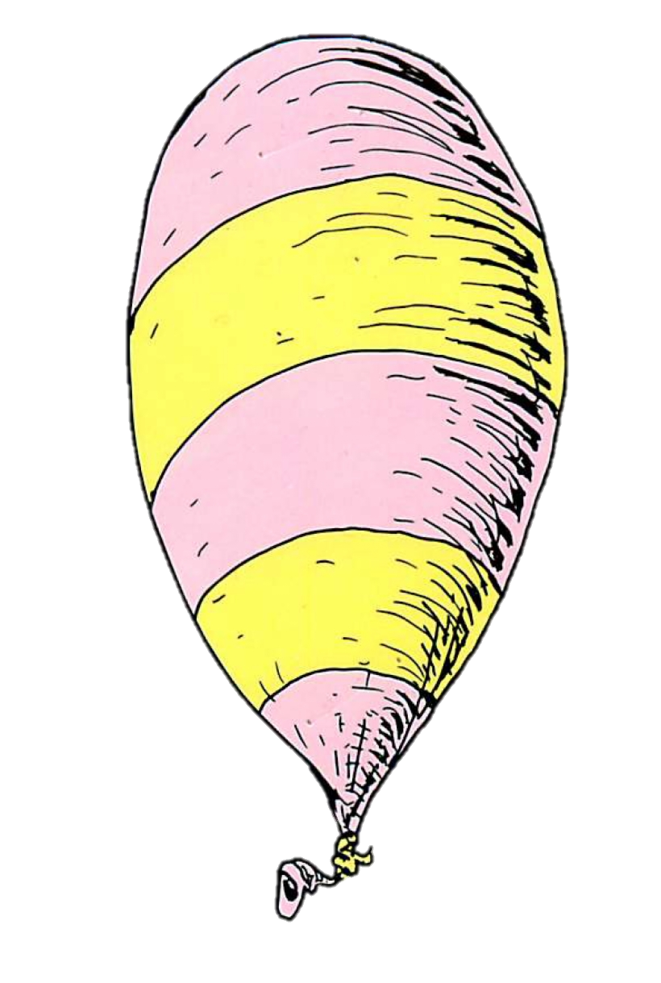
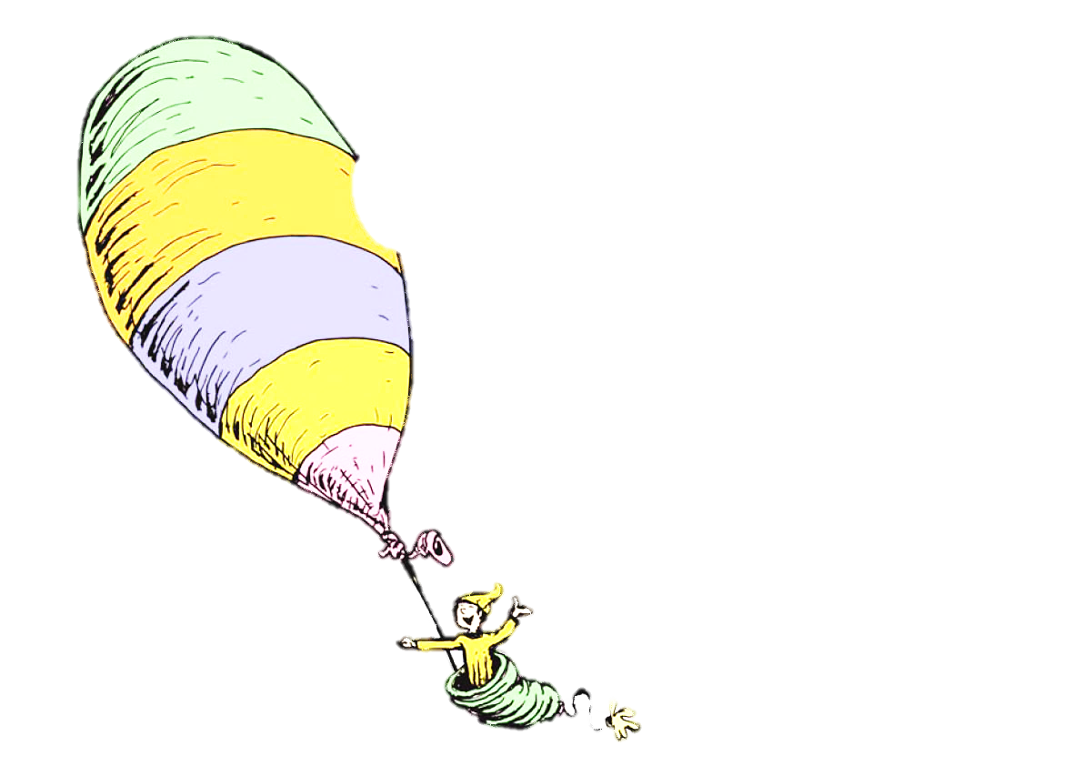
You’re off to Great
Places!
Today is your day!
Your MOUNTAIN is waiting,
So . . . get on your way!

Unless Someone Like YOU Cares a Whole
Awful Lot, Nothing is Going to get Better. It’s Not.
March | 2020
Sunday | Monday | Tuesday | Wednesday | Thursday | Friday | Saturday
1 | 2 | 3 | 4 | 5 | 6 | 7 | Notes  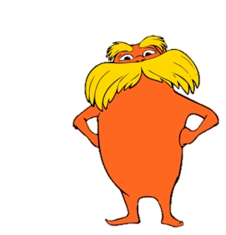  _______________________________________________________________________________________________________________________________________________________________________________________________________________________________________________________________________________________________________________________________________________________________________________________________________
8 | 9 | 10 | 11 | 12 | 13 | 14
15 | 16 | 17 | 18 | 19 | 20 | 21
22 | 23 | 24 | 25 | 26 | 27 | 28
29 | 30 | 31
Teacher Michelle

April | 2020
Sunday | Monday | Tuesday | Wednesdayy | Thursday | Friday | Saturday
 |  |  | 1 | 2 | 3 | 4 | Notes    _______________________________________________________________________________________________________________________________________________________________________________________________________________  
5 | 6 | 7 | 8 | 9 | 10 | 11
12 | 13 | 14 | 15 | 16 | 17 | 18
19 | 20 | 21 | 22 | 23 | 24 | 25
26 | 27 | 28 | 29 | 30
Teacher Michelle

“A person’s a person, No matter how Small.”
May | 2020
Sunday | Monday | Tuesday | Wednesday | Thursday | Friday | Saturday
 |  |  |  |  | 1 | 2 | Notes  _______________________________________________________________________________________________________________________________________________________________________________________________________________  “Only You Can Control Your Future .”
3 | 4 | 5 | 6 | 7 | 8 | 9
10 | 11 | 12 | 13 | 14 | 15 | 16
17 | 18 | 19 | 20 | 21 | 22 | 23
24 | 25 | 26 | 27 | 28 | 29 | 30
31


Teacher Michelle

June | 2020
Sunday | Monday | Tuesday | Wednesday | Thursday | Friday | Saturday
 | 1 | 2 | 3 | 4 | 5 | 6 | Notes  _______________________________________________________________________________________________________________________________________________________________________________________________________________    ____________________________________________________________________________________________________________________________________________
7 | 8 | 9 | 10 | 11 | 12 | 13
14 | 15 | 16 | 17 | 18 | 19 | 20
21 | 22 | 23 | 24 | 25 | 26 | 27
28 | 29 | 30
Teacher Michelle

“Today You are YOU, that is Truer than True. There Is No one Alive who is Youer than You.
Teacher Michelle
July | 2020
Sunday | Monday | Tuesday | Wednesdayy | Thursday | Friday | Saturday
 |  |  | 1 | 2 | 3 | 4 | Notes  _______________________________________________________________________________________________________________________________________________________________________________________________________________  
5 | 6 | 7 | 8 | 9 | 10 | 11
12 | 13 | 14 | 15 | 16 | 17 | 18
19 | 20 | 21 | 22 | 23 | 24 | 25
26 | 27 | 28 | 29 | 30 | 31
I Do Not Like Green Eggs and Ham, I do Not Like Them Sam I Am.
I bet You Know a Thing or Two!
You’re SuperSmart!
I’m proud of You!

August | 2020
Sunday | Monday | Tuesday | Wednesday | Thursday | Friday | Saturday
Notes
_______________________________________________________________________________________________________________________________________________________________________________________________________________
____________________________________________________________________________________________________________________________________________

 |  |  |  |  |  | 1
2 | 3 | 4 | 5 | 6 | 7 | 8
9 | 10 | 11 | 12 | 13 | 14 | 15
16 | 17 | 18 | 19 | 20 | 21 | 22
23 | 24 | 25 | 26 | 27 | 28 | 29
30 | 31
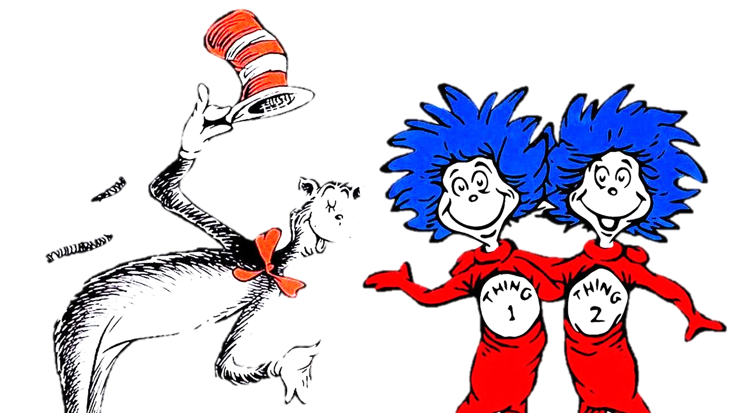
Teacher Michelle

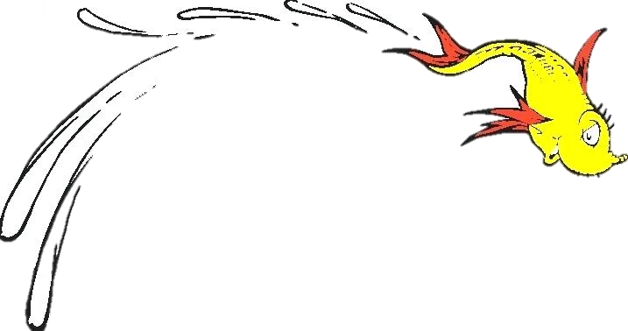
Teacher Michelle

September | 2020
Sunday | Monday | Tuesday | Wednesday | Thursday | Friday | Saturday
 |  | 1 | 2 | 3 | 4 | 5 | Notes  _______________________________________________________________________________________________________________________________________________________________________________________________________________  ____________________  From there to here,  From here to there,  FUNNY things are  EVERYWHERE.
6 | 7 | 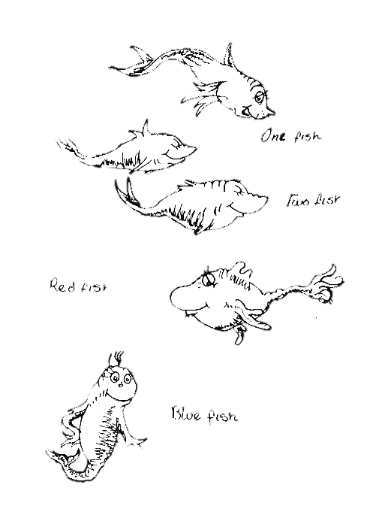  8 | 9 | 10 | 11 | 12
13 | 14 | 15 | 16 | 17 | 18 | 19
20 | 21 | 22 | 23 | 24 | 25 | 26
27 | 28 | 29 | 30

October | 2020
Sunday | Monday | Tuesday | Wednesdayy | Thursday | Friday | Saturday
 |  |  | 1 | 2 | 3 | 4 | Notes  _______________________________________________________________________________________________________________________________________________________________________________________________________________________________________  THE
 |  |  | “Then the Grinch thought of something he hadn't before! What if Christmas, he thought, doesn't come from a store. What if Christmas...perhaps...means a little bit MORE!”
5 | 6 | 7 | 8 | 9 | 10 | 11
12 | 13 | 14 | 15 | 16 | 17 | 18
19 | 20 | 21 | 22 | 23 | 24 | 25
26 | 27 | 28 | 29 | 30
 |  |  |  | Teacher Michelle
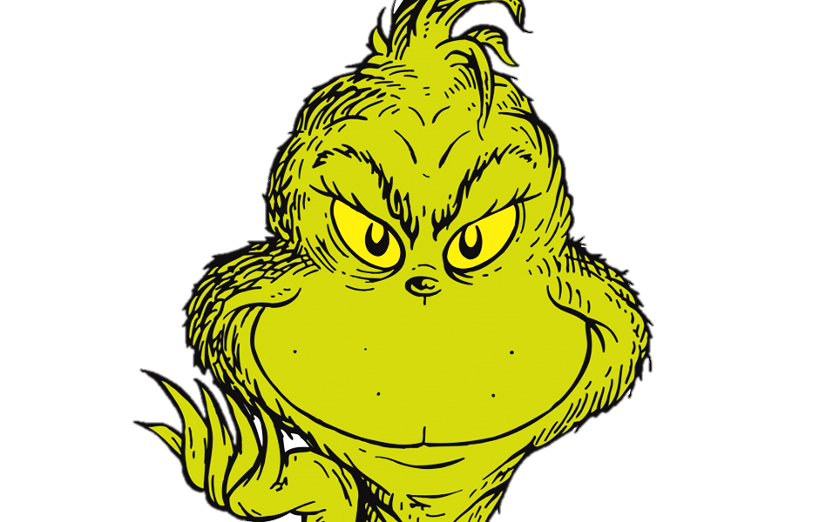
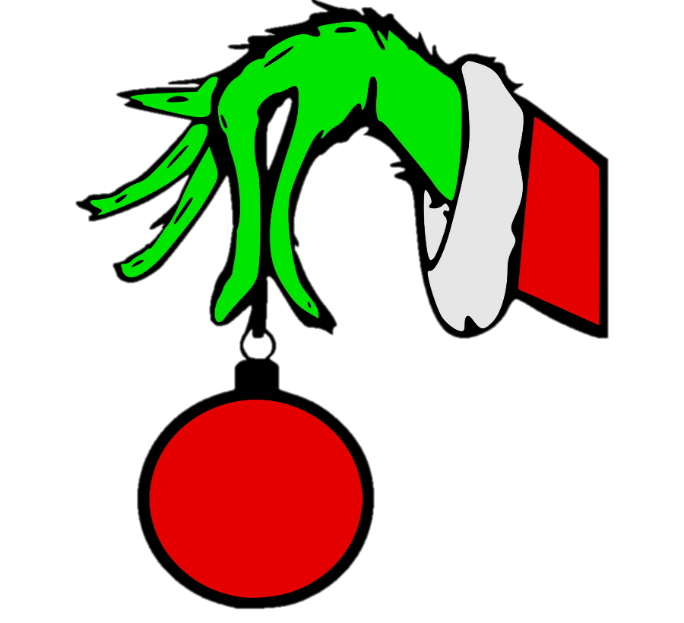
GRINCH
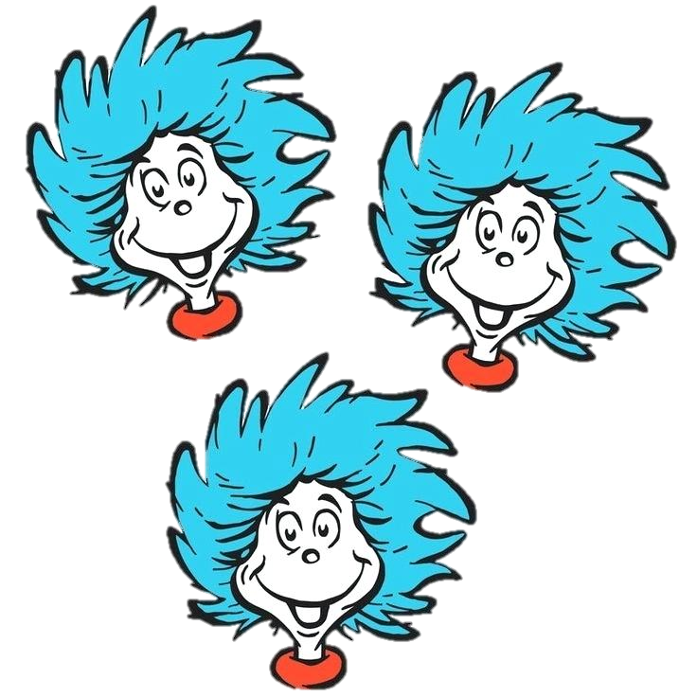
Teacher Michelle

November | 2020
Sunday | Monday | Tuesday | Wednesday | Thursday | Friday | Saturday
1 | 2 | 3 | 4 | 5 | 6 | 7 | Notes  _______________________________________________________________________________________________________________________________________________________________________________________________________________________________________________________________________________________________________________________________________________________________________________________________________
8 | 9 | 10 | 11 | 12 | 13 | 14
15 | 16 | 17 | 18 | 19 | 20 | 21
22 | 23 | 24 | 25 | 26 | 27 | 28
29 | 30

December | 2020
Sunday | Monday | Tuesday | Wednesday | Thursday | Friday | Saturday
 |  | 1 | 2 | 3 | 4 | 5 | Notes    _______________________________________________________________________________________________________________________________________________________________________________________________________________________________________________________________________________________________________________________________________________________________________________________________________  ____________________
6 | 7 | 8 | 9 | 10 | 11 | 12
13 | 14 | 15 | 16 | 17 | 18 | 19
20 | 21 | 22 | 23 | 24 | 25 | 26
27 | 28 | 29 | 30 | 31
Teacher Michelle
“The more that you read, the more things you will know. The more that you learn, the more places you'll go.”

