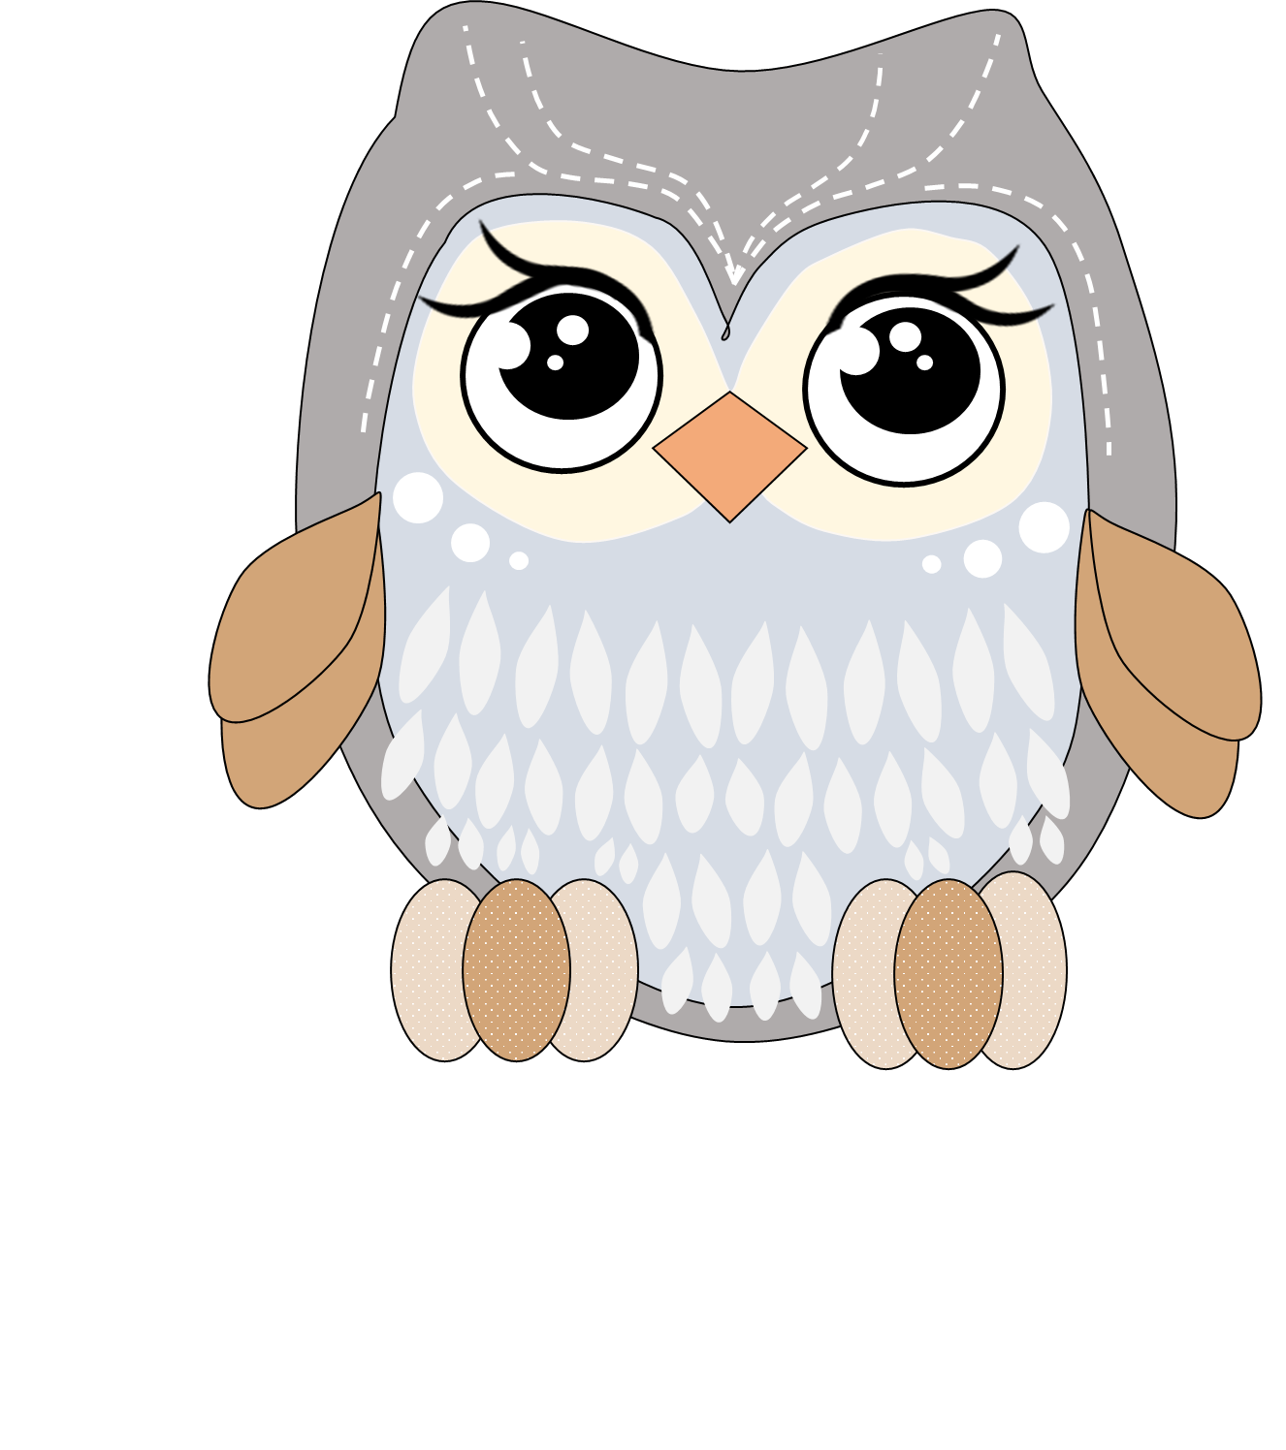
Grade 3
Teacher Carla

