
Mathematics
Assessment Term 2
Grade 1

Name and surname: ____________________________
Date: _________________________________

TASK 2

Content area |  | Mark
- Numbers, operations and relationships | 20
- Patterns, functions and algebra | 10
- Space and shape | 5
- Measurement | 10
- Data handling | 5
Totaal | 50
Numbers, operations and relationships

  - Count the following objects. Count in groups to help you. (3)

- How many fingers do you count? (1)
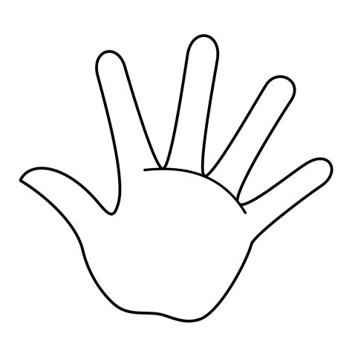
=

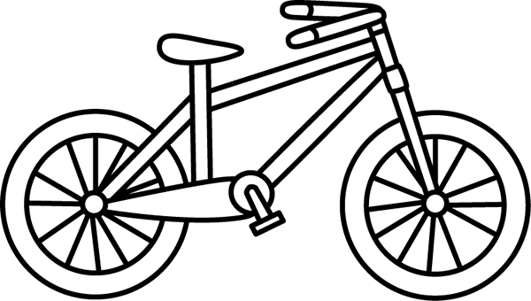
- How many wheels do you count? (1)

=

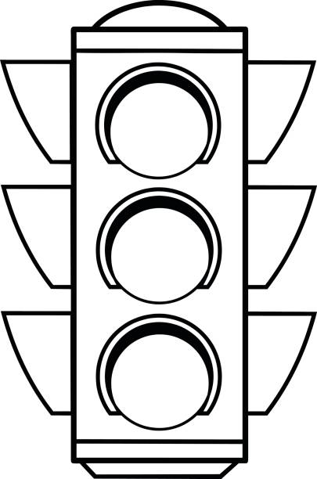
- How many lights do you count? (1)

=
  - Complete - Count backwards and forwards (14¸2 =7)
    - 2, 4, 6, ___, ___. ___. (3)
    - 5, 10, 15, ___, ___, ___. (3)
    - 10, 20, 30, ___, ____. (2)
    - 50, 40, ___, ___, ___. (3)
    - 35, 30, 25, ___, ___. ___. (3)

  - Complete the table with the correct number names and number symbols. (4)
Number name | Number symbol
eight
 | 10
 | 5
six

  - What is before, after or between? (6¸2 = 3)
after
19
27

before
4
25
between
4 |  | 6
14 |  | 16


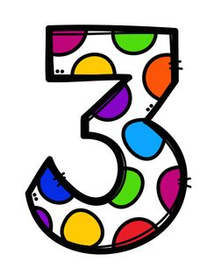
  - Study the numbers in the circles and answer the questions. (8¸2 = 4)
2
5
3
9
11

- Write down the numbers from the smallest to the biggest. (1)
________________________________________
- Write down the numbers from the biggest to the smallest. (1)
________________________________________
c. What number is 1 more than 6? ________
d. What number is 1 less than 9? ________
e. What number is 2 less than 10? ________
f. What number is 2 more than 2? ________
g. What number is 3 more than 9? ________
h. What number is 3 less than 6? ________

1.6 Break down the following numbers into tens and ones. (4)
Number | Tens | Ones
11
13

  - Use the number line to help you do the following plus and minus sums. (8¸2 = 4)
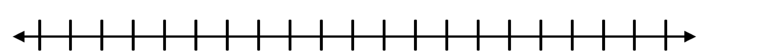
0 1 2 3 4 5 6 7 8 9 10 11 12 13 14 15 16 17 18 19 20
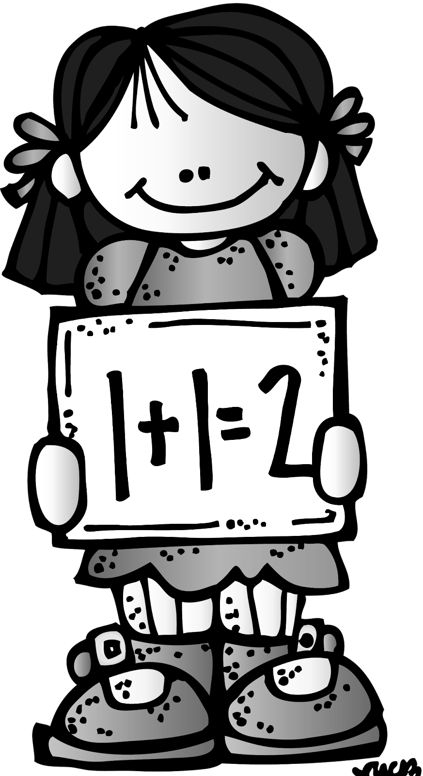
5 + 2 = _____
10 - 2 = _____
4 + 6 = _____
6 - 2 = _____
2 + 2 = _____
12 - 2 = _____
9 + 4 = _____
15 - 4 = _____


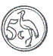

1.8 Write down the names of the coins. (4)
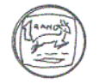
Twee rand

__________ __________ ___________ ___________

  - Repeated addition -
Complete the following sums. (5)
- 5c + 5c + 5c = __________
- 10c + 10c + 10c + 10c = _________
- R2 + R2 + R2 + R2 + R2 = _________
- 20c - 10c = _______
- 20c - 5c - 5c - 5c = ________
  - Double the number of dots on each butterfly by drawing the correct number of dots on the empty wing. (4¸2 =2)
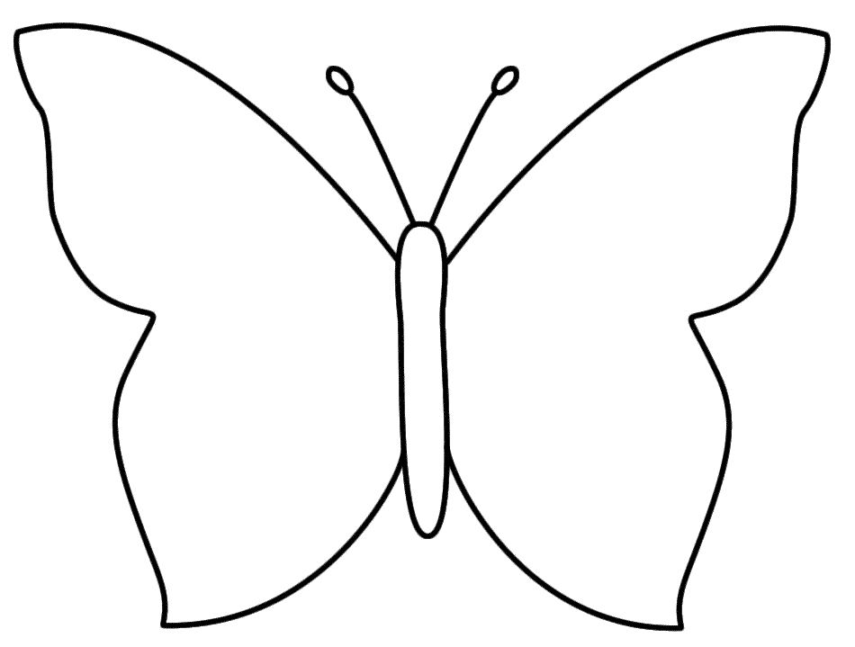

Numbers, operations and relationships |  | Mark
- Counting | 3
- Counting forwards and backwards | 7
- Number names and number symbols | 4
- Order of numbers | 3
- Study the numbers in the circles and answer the questions | 4
- Decomposing of numbers | 4
- Number lines - plus and minus | 4
- Write down the names of the coins | 4
- Money problems | 5
- Doubling | 2
Total | ___/40
Amended mark out of 20 | 40 ¸ 2 = ___/20
Patterns, functions and algebra

2.1. Geometric patterns
Complete the patterns by drawing the next shapes. (2)

2.2. Colour the shapes to form a pattern. (2)

red
yellow
blue

green
purple

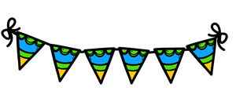
2.3. Number patterns - Complete the numbers on the flags by either counting forwards or backwards. (12¸2 = 6)
10 20
10
8
6
25 35

20 24 26


45
40
35

Patterns, functions and algebra |  | Mark
- Geometric patterns - draw | 2
- Geometric patterns - colour to form a pattern | 2
- Number patterns | 6
Total | 10

Space and shape

3.1 Count the shapes and write down the name of each shape. (8¸2=4)

 | Name of shape | How many shapes do you count?
3.2 Colour the shapes according to the following:
Space and shape |  | Mark
- Count the shapes and shape names | 4
- Rounded and straight sides | 6
Total | ___/10
Amended mark out of 5 | 10 ¸ 2 = __/5
a. Colour the shapes with straight sides BLUE.
b. Colour the shapes with rounded sides YELLOW.
(6)

Measurement

4.1. Number the pictures from youngest to oldest, write down 1,
2, 3 and 4. (4)
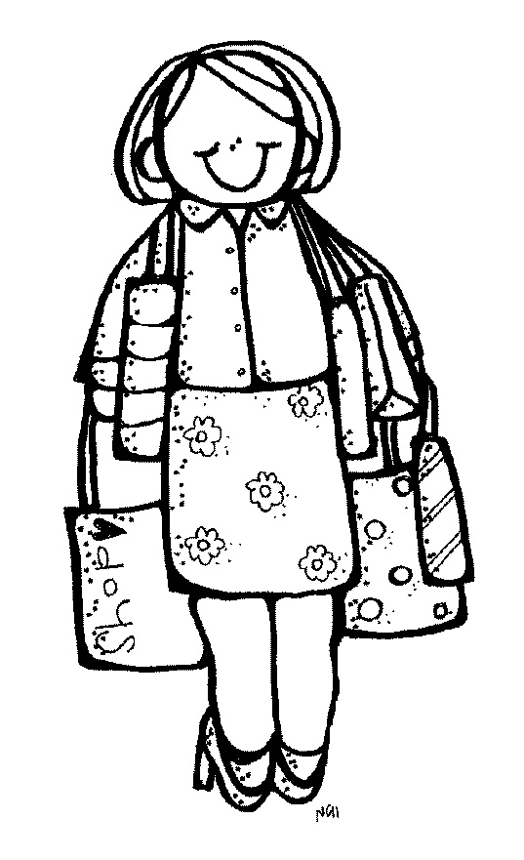
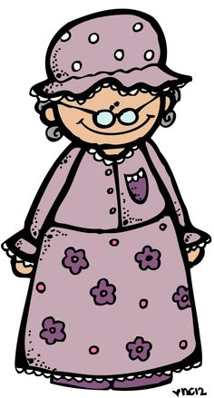
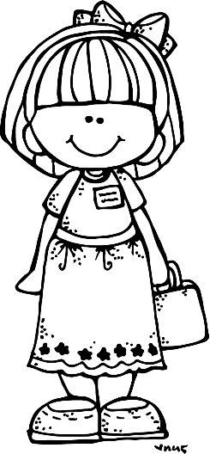

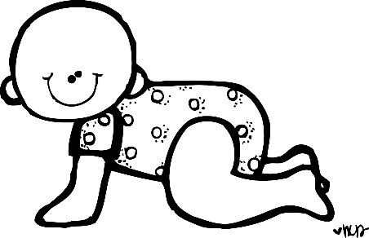



4.2. Which friend is the tallest? Look at the friend with the
arrow, is the friend next to him shorter or taller? (2)
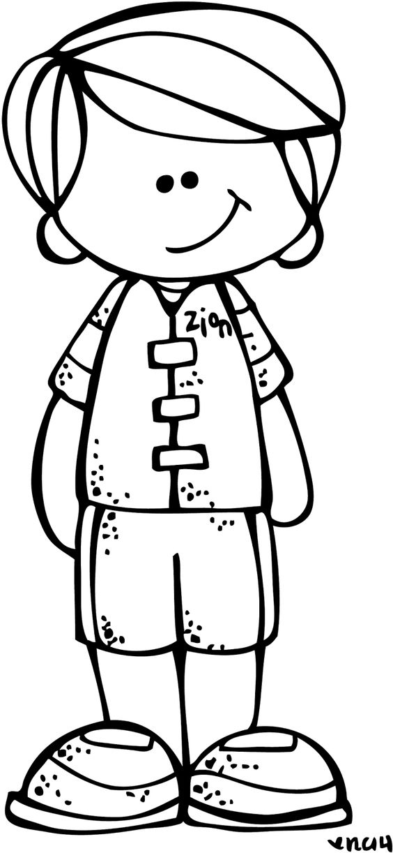
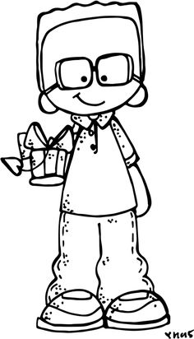
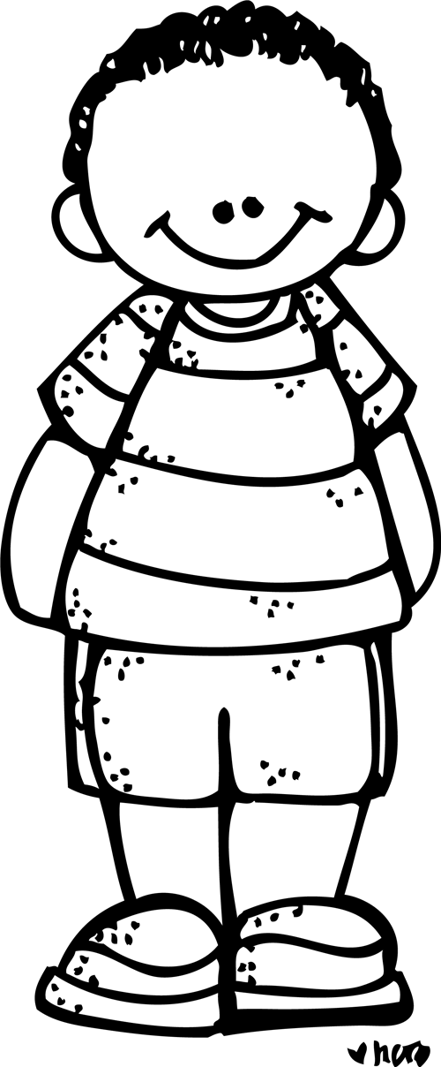

shorter
taller

shorter
taller

4.3. Study the pictures below and answer the questions.
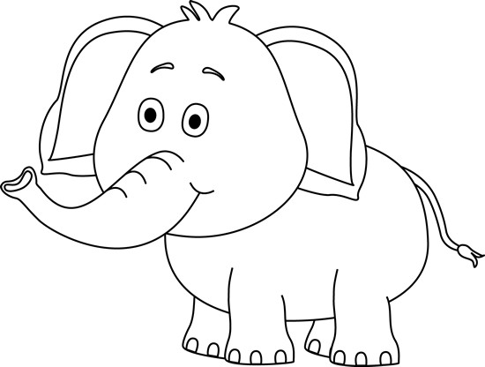

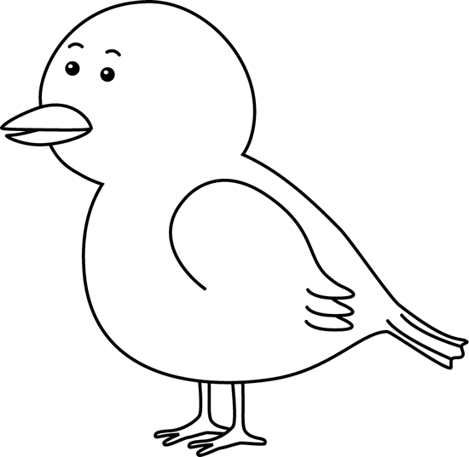
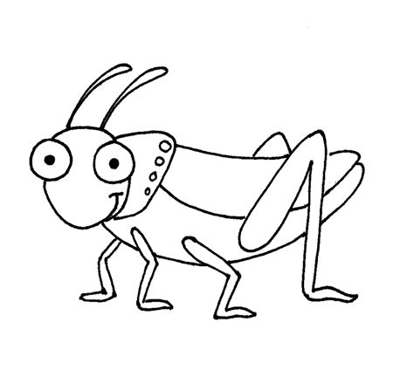

bird
elephant
grasshopper

- Which animal is the heaviest? _______________
- Which animal is the lightest? __________________

4.4. Colour the pictures as follow: (4¸2 = 2)
- Colour the glass with the most water YELLOW. (1)
- Colour the glass with the least amount of water BLUE. (1)
- Colour the glasses with equal amounts of water PURPLE. (2)
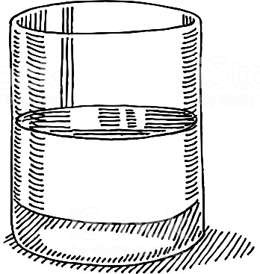
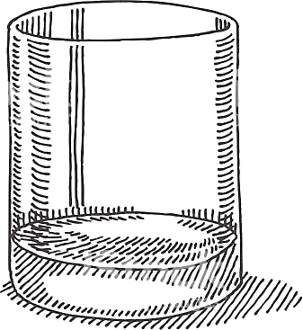
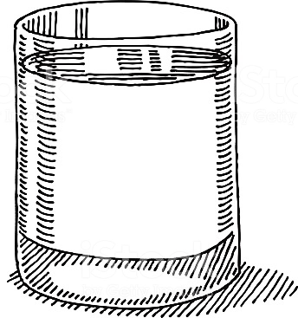

Measurement |  | Mark
4.1. Youngest to oldest | 4
4.2. Length | 2
4.3. Mass | 2
4.4. Volume / capacity | 2
Total | ___/10

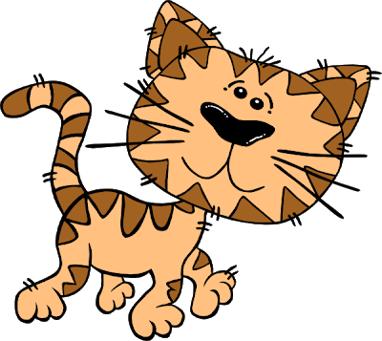
Data handling
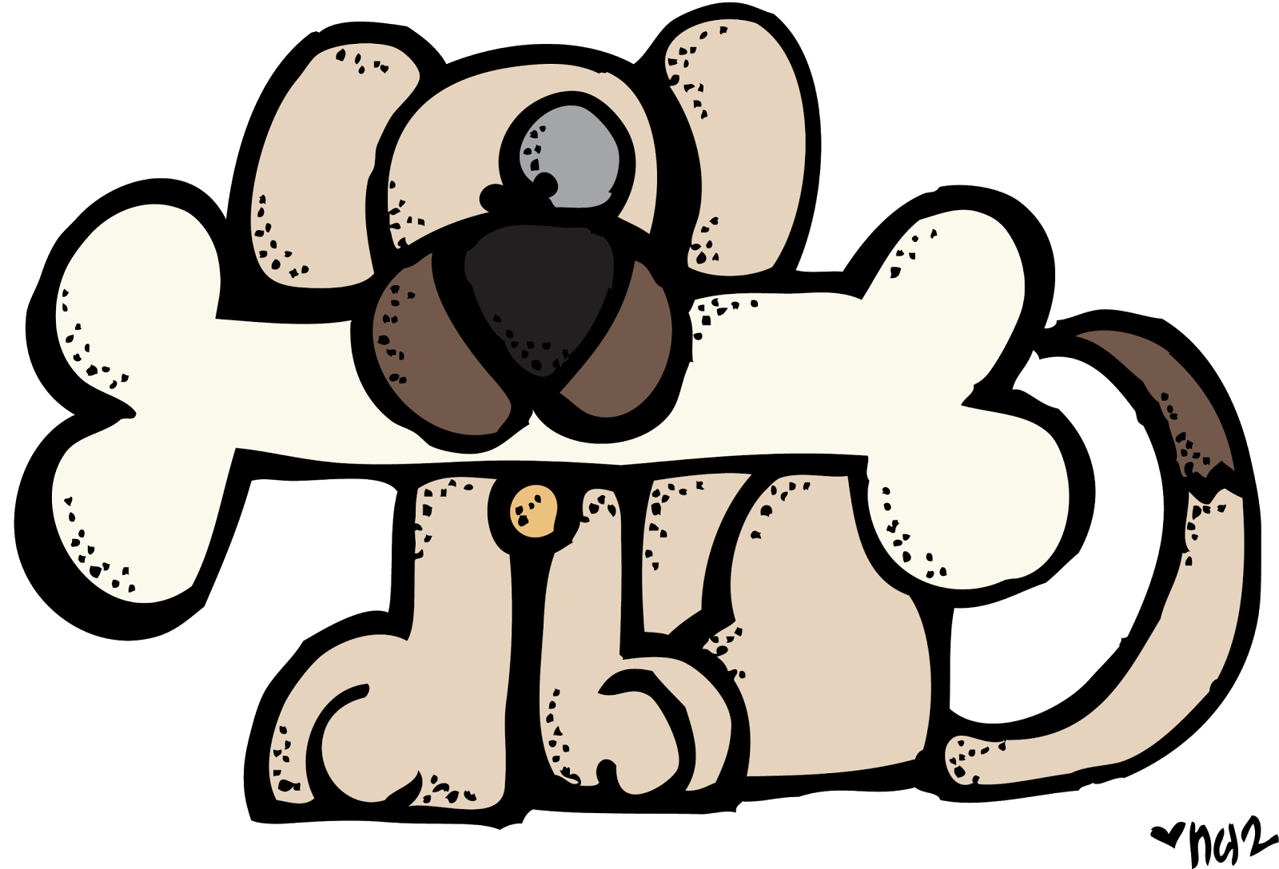
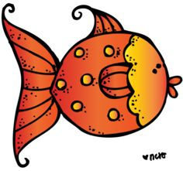
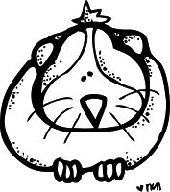

Favourite pet
Study the graph and answer the questions.

dog cat parrot fish hamster
10
9
8
7
6
5
4
3
2
1

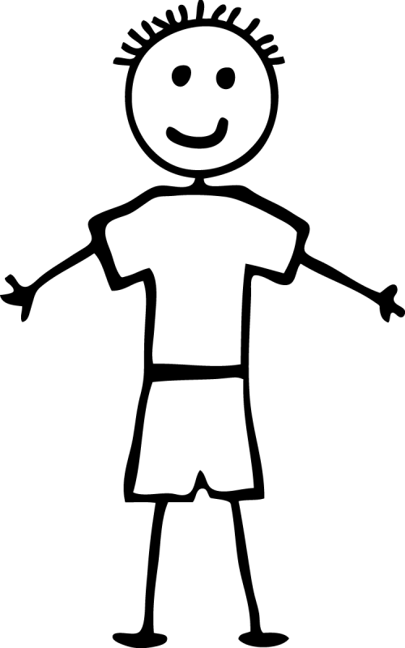

- Which pet is the children’s favourite? _____________
- Which pet is the children’s least favourite? _____________
- How many children likes dogs? ______________
- How many children likes parrots? __________
- How many children are there in total? ____________

Data handling |  | Mark
- 1 point for each question correctly answered. | 5
Total | 5

